An envelope of high quality parchment arrives bundled with your other correspondence addressed simply with “To Whom it May Concern.”

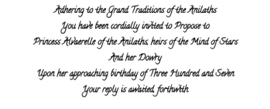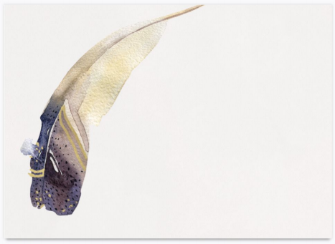

Directions included within the envelope instruct a Currier how to navigate letters addressed to Princess Alvaerelle into a specific region of the Ultralands.

Additionally, the envelope contains the following painting and inscription.

Why don’t you see me? 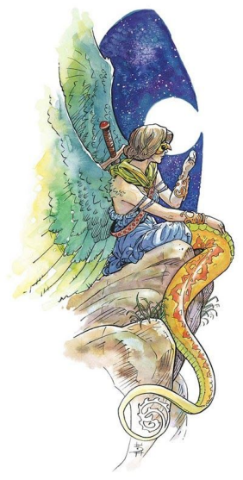

Invisible like starlight

I ping between skies

\*

Invisible like starlight

It takes forever

To get your attention, dear

\*

It takes forever

For you to touch me

Like I wish you would

\*

For you to touch me

I have to traverse planets

Why don’t you see me?