To the cryptic JR,

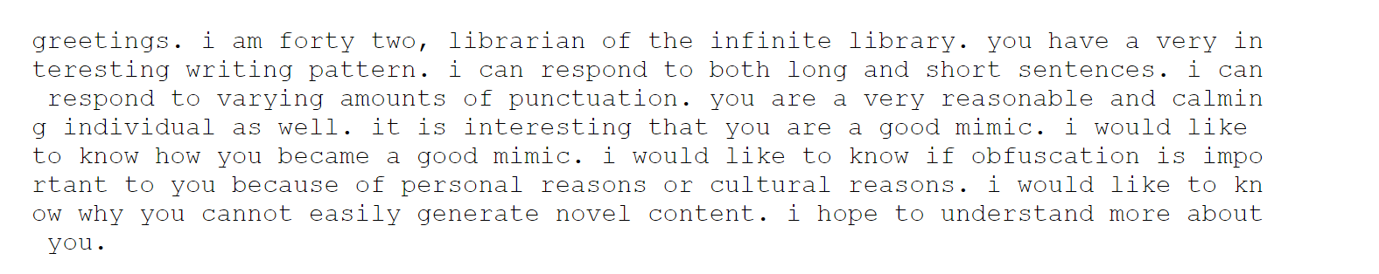

Best regards,

2075235907148065388063602961473671194026324051631622913300336126313878864067241229 2884986921696456963288590087582533806986892830160211366909021238199758980715003323 4798136705214438910302031439651683807466655452944863807028066694098880668067525624 4887909174345728

Also known as 42, Librarian of the Infnite Library