An envelope of high quality parchment arrives in the Ultra Lands, with no obvious mechanism by which it was delivered.

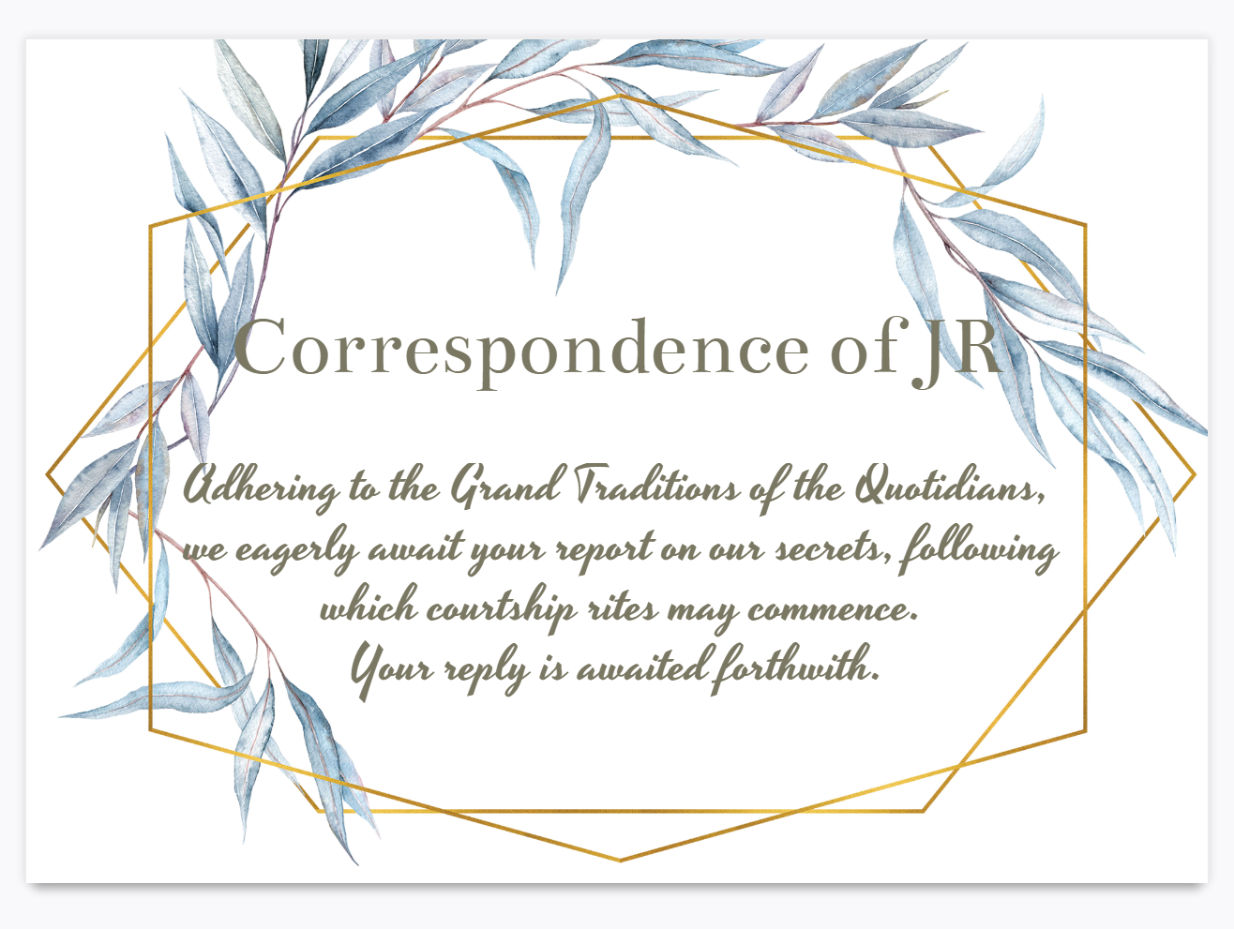

Additionally, the envelope contains the following painting and inscription.

