january:

>rem 14d tell robin to plan a heist of yellows knowledge, targetting anything genocide tier. goal is to leave yellow with NO ability to do anything like this ever again

plus give pink a flock of crows as a trade/spy asset

* 25 wealth total available

**Priorities**:

1. Support Pink in ALL ways, they are BESTIE
   1. They have SUBSCRIBED TO OUR NEWSPAPER. Spin up a newsie team to deliver news/history/data to them and any other country. They offer calories in exchange(provide wealth for this).
   2. Eliminate ALL rats coming from our lands to theirs. Eliminate every rat you can find within their border, especially where they border other countries (see internal report B for knowledge of GREEN)
      1. Attached are historical records on one "Alberta" who was capable of eliminating all rats, and their tactics.
   3. Support The Coven of the Bloodless Rose, especially within the ULTRALANDS
   4. Prioritize finding information on them so we can show them we care
2. FRIEND hired us for a job. Investigate the ultralands pool of teeth (see FRIEND report B)
3. RED is an asshole. Sow seeds of dissent against them. Investigate counter measures to their mind binding (detection, prevention, disruption, etc)
4. YELLOW is obviously spies but seems like they'd be a good customer. Their magical data is USEFUL.
   1. They have ALSO subscribed to our NEWSPAPER. They offer knowledge and trade secrets in exchange.
5. Preserve SHELLFOLK culture and samples
6. KILL GREEN RATS I guess
   1. Use NEWSPAPER to distribute PROPAGANDA against rats

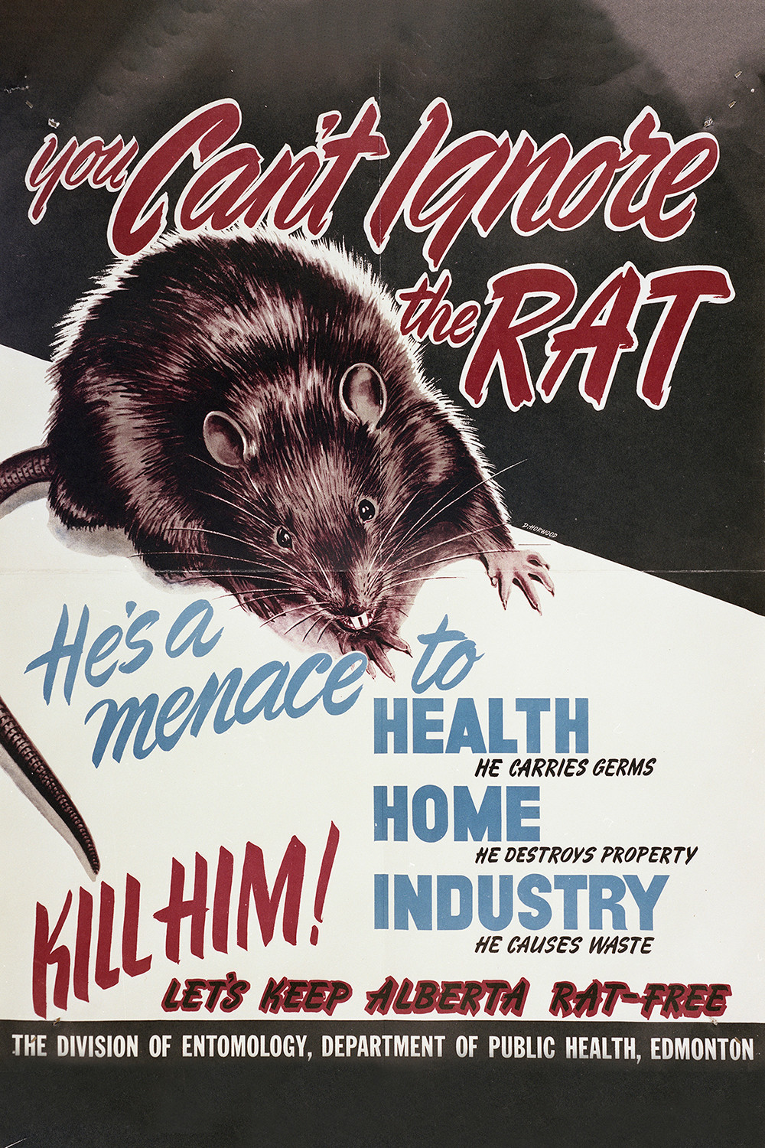

* superb work on framing red for trying to assasinate green. i'll send you a bonus.
* We have gotten our first job: a mysterious **FRIEND** offers us compensation should we enter the UltraLands and seek the Pool of Teeth
  + . So long as we are seeking it it will take three days to reach it, and then as long as we seek to leave it will take three days to leave.
  + No one dies in the UltraLands. (Don't trust this, but it might be useful to keep that in mind when looking for signs of our lost spies)
  + while you're there, look for info on pink's 'enemy' (see below)
* Pink is our BESTIE
  + In general, pink seems a useful trading partner, and has asked us to demonstrate our skills by showing the knowledge we have on them. This was obviously very sudden, and we did not have much to show. We may want to bring our a game to uncovering more to them to offset the embarassement
  + pink is sending us info on red, and wants us to get along with them
  + pink claims actionable intelligence on an "enemy", "likely in the Ultralands". that is a threat to all of Bellor. We cannot allow a genocide.
  + Pink has agreed to a subscription to our NEWSPAPER. We should send information we gather to pink as well, in exchange for goods and services (manic, this means they'll get a prosperity modifier as well as data right?). Pink also says we are free to gather data in their lands as much as we want as long as we don't sell it to others. we should prevent other nstions from gsthering data on pink, this is OUR bestie
  + If you see Pink's people in the Ultra lands, assist them however possible (witihout exposing corvidification). The Coven of The Bloodless Rose contains pink's daughter.
* Red is an asshole. Does anyone else hate them? might be useful to feed info to their enemies
  + they raided us and burned "WE DEMAND RESPECT" into one of our cities. we aren't entirely sure what that means (evolved creatures use "respect" to indicate leadership and dominance within in-groups. they are neither in our in-group nor our leader (and if they are threatening to become our leader we need to work harder to counter their mind binders). Respond however you like, up to and including with secret arson writing a response. ( we don't know what meaning of respect they are trying to use, but we don't like them and don't want to be friends, if friendship is what is happening here)
* Yellow is obviously spies and is installing a "Trade Embassy" in our lands. They are also our best buyer for our store of magical secrets. What more can we learn about them? Are they bestie potential? They seem to be the inheritors of the culture which we are most familiar with
  + Yellow ALSO wishes a subscription to our NEWSPAPER, in exchange for VALUABLE MAGICAL and HISTORICAL KNOWLEDGE.
* transmit all internal data , along with some wealth
  + ask robin why butterflies migrated early
* preserve what we can of shellfolk culture, make sure they dont go extinct, maybe infiltrate their refuges more explicitly than we would a full nation