<http://farragofiction.com/AdventureSimWest/?nostalgia=backup.txt>  
Saved On: 7/21/2022 11:53:35 AM  
The Universe is in Safe Mode.

> Reset The Loop

In front of you are a total of 7 beasts.

1. the smallest of them, its head is especially bulbous.
2. this one has very large, very shiny teeth
3. this one is ...wearing seaweed as a hat?
4. this one is monotonously chewing on a chocolate bar
5. this one's head lumps go down its neck
6. this one appears to have rolled in some feathers
7. this one is a fractaling nightmare

You are holding a Pistol with 7 Bullets.

> Look Around

Near the Beasts, you see an inkbot with a note next to it.

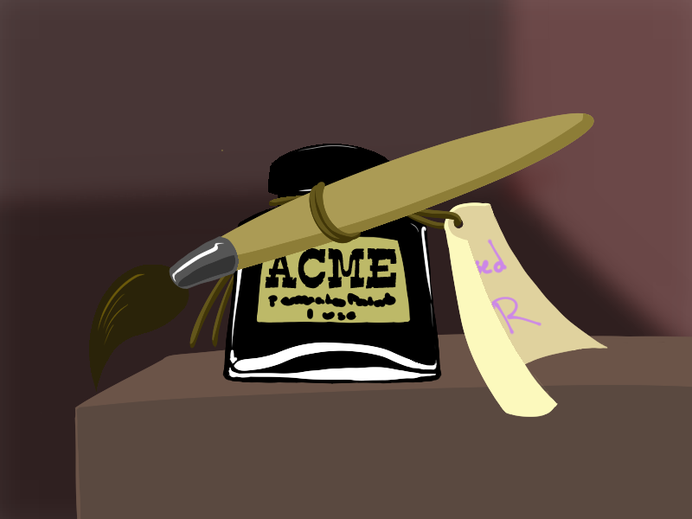

When you examine further...

You guess that one Observer wasn't kidding about their Relevance Quotient. Your GAMER INSTINCTS let you know that you can use this item before killing a BEAST... though you're not sure what will happen if you do.

> Let's try it

> avail ink on self along with brush

INPUT ACCEPTED: What Are You Painting On Your Skin?

> Hibernate until March 30, 2022. If we're going to reset anyway, I want to see how the last day before the reset goes.

You're locked into the Control Menu for the Reality Ink, but your GAMER INSTINCTS let you know that while Hibernating within the Timeless Maze is almost pointless (unless you're feeling Doomed Enough), Beast 7 right there will get you where you need to go.

> eyes

You cover your skin with drawings of eyes.

It doesn't occur to you what you're doing, at first, as you draw eye over pupil and eye over pupil everywhere where there is room to so so.

Then, you feel it, as the last of the ink dries: there's a horrid pain bubbling behind your eyes. You go to rub them, hoping to ease it somewhat.

And then, it begins to boil.

Skin splits at every ink stroke, tearing itself apart on the spot as patches bulge outward with some slimy _something_ rolling inside of them, growing bigger and more frantic the more you think about it. Like an overgrown cyst, one by one, they all pop from the pressure, your vision doubling again and again and again. Your tongue feels dry and your limbs heavy. The wave of dizziness hits you as your mind struggles to process all the additional input.

You can feel your skin *blink*.

With a mounting horror, you realize the Observers have forced you to take on the appearance of the hated False Nidhogg.

> Hit that 7th beast woooo

You have to get right up point blank, you...kind of can't figure out depth perception with this many eyes, (and also the fractal beast is kind of hard to see to begin with ) but you shoot the 7th beast.

## **2022 March 30th: 9:00 am**

The pervading feeling of Doom settles into your bones. You will not need Gamer Fuel or eggs, your time here has an extremely hard limit that is rapidly approaching. You have all of today, and all of tomorrow till Midnight to learn what you can.

You are standing outside Eyedol HQ, a few pedestrians run screaming at one look at your grotesque, eye covered form. Fun.

> get used to the eyes. try closing them all, then opening them one or two at a time

You do your best to get over the disorientation and mirroring of your vision. Your GAMER CYBERNETICS helpfully start activating Picture In Picture mode so...you GUESS it's not too bad? You just wish you didn't look like some kinda Nidhogg Minion....

> get in there

> wait no examine surroundings first. is anything else obviously fucked up in some way

Besides there not really being anyone around after they all fled, its seems like a relatively normal day?

> great day. primal thoughts.

You bask in the morning sunshine for a bit.

> might as well go inside, then.

You're about to go inside when a woman dashes out the door slightly out of breath, flagging you down.

She makes eye contact with you as she catches her breath, hands on her knees,clearly startled (but not scared) by your new eyes. Her bouncy blonde hair seems just a bit out of place from her mad dash.

Finally, she looks up at you and offers a hand. "Peewee Cassan, is it not? Pleasure to meet you, Dr. Fiona Slaughter."

> Wrap around her like a snake. Exert your dominance

She tenses up slightly, then evenly, firmly, says. "Peewee. I apologize if I have done anything to offend you, but this is not appropriate behavior. Please, let me go."

Your various eyes feel *weird* pressed against her. You don't like it, so you let her go. Not for any other reason. Not because she's weirdly intimidating with how calm she was.

> shake hand

You offer to shake her hand. She straightens out the clothing you rumpled (white with pink accents, formerly flawless despite her running). She spends a full second staring at your offered hand, then takes it, delicately. You don't like the way the eye in your palm feels squished.

"That is much better, thank you, Peewee".

> Glad to see we can still be identified in our Nidhogg'd state. Accept the greeting and ask her what's up.

You still look like yourself. You're just covered in eyes. It's gross and you hate it.

> "what brings you running to meet us?"

She raises a perfectly groomed eyebrow. "Us? Ah. Yes, my notes did say you had some...how was it phrased. Observers?"

She takes a half step back from you and pulls something out of her perfectly coordinated bag. "My card. My services as a psychotherapist have been put on offer for all those experiencing the Loop, free of charge, courtesy of a variety of patrons. Most notably, one calling herself The Closer, and one calling herself The End."

You still haven't taken the card because you're kind of worried it'll be gross to touch with your eye hands, but she holds it out in front of her unwavering.

"My services are, of course, entirely optional. But please do keep me in mind should you want an outside viewpoint on your struggles."

> Ask her why the Closer is involved. She's the one who made the deal with you for favors to escape the hell eye maze. Didn't seem the type to do things for free.

She smiles easily, eyes crinkling, chuckling lightly. "You seem familiar with her... ", she pauses, eyes going back and forth as if trying to remember something extremely specific.

"Unfortunately, confidentiality laws do prevent me from saying MOST things that would answer your question, however I do believe I am allowed to say that it was in order to discharge a debt owed?"

She brightens "And that it wasn't to benefit you in particular. Just those in the Loop more broadly. Barring one notable exception, of course."

> who is it. it's not us is it

She smiles "If it was, I would not, legally speaking, be able to offer you therapy!"

The card is still held between the two of you, waiting to be picked up. She's not showing any signs of impatience, just calmly waiting for you to make a decision.

> taking the card doesn't commit you to using it, you just have more options. take it.

> Take the card and ask if she does family counseling.

You take the card, which has her name and contact information on it in swirly font, and ask if she does family counseling.

She frowns. "I admit it isn't one of my specialties. I'm sure I could recommend a good one to you, though some of the more..." She pauses here, visibly searching for a polite word "*esoteric* cases can be intimidating for the vast majority of my collogues. " She is keeping her eyes firmly on the two on your face, and now any of the various ones peering up at her from the rest of your body.

> "do you know that the world is going to end tomorrow?"

Her bubblegum pink lips form a thin line. "I have heard similar rumors. I've been assured that 'The End Is Never The End', but I must admit I have no idea what that could even mean. " She brightens. "Though as I always say there's always time for Therapy, even at the end of the world!"

She glances at a tasteful watch on her wrist. "I'm afraid I must be going, though! Lovely meeting you, Peewee, and do contact me should you decide therapy is an option!"

> try to commit her contact info to memory - you may not have time to use it this Loop

Luckily your GAMING CYBERNETICS handle that for you.

Doc Slaughter stops waiting to see if you'll acknowledge your goodbye and hurries back into Eyedol HQ.

You feel a dizzying wave of possibilities before you. You could go anywhere, you could do anything!

> We're going to Disney World!

> Cool! We got access to therapy! Anyway Time to noclip to the center of the earth again

> We're going to Disney World!

> go to disney world

A D4 deep in your circuits decides...Disney it is!

You head into the Eyedol HQ offices and use your SWEET GAMING SPEED RUNNING powers to refind the Skyrim Fast Travel room and find yourself in a roiling sea of humanity, determined to have fun and make this overpriced vacation worth it.

You never really went to the Segundian Equivalent of this kind of thing, but you guess you've seen ads and weirdly compelling four hour documentaries on queuing algorithms?

It all seems about what you'd expect, besides all the eyes everywhere, all the time. Eye rides. Eye games.Eye motifs worked into bricks on walls and roads. Eye balloons tied to eye lampposts. Eye baubles hanging from trees. Vendors selling eye shirts and eye icecream. It's. Huh. They sure are going hard on the theming.

In a soothing turn of events, instead of screaming and running away, the massed crowds start asking you for autographs and complimenting your makeup. It seems they assume you are a staff member?

> Sign their autographs. Then no clip into the center of the Earth

You hold the pen in your stupid eyeball hands and sort of mange to scrawl something out without poking yourself painfully.

You hear a few screams as you sink into the very earth, so good to know some things are consistent.

You gear yourself up for a really solid no clip session only to THUNK painfully against ....huh. Looks like you're in some kind of cast member tunnel underneath the park itself?

The CEBro glances up from her phone then springs up from where she was slouched against a wall.

"Peewee!" she says, taking some celebratory selfies with you, getting distracted half way through answering a text and then focusing on you again.

"Great to see you bro! Sorry about the whole failed no-clip thing, you're kinda in my domain, you know? Spacey thing and all? I wasn't about to let you wander off without saying hi! It's been so long!"

> "It has been. What, missed you this entire loop, huh?"

> You guess it's been at least a whole loop.

> aw, it can't have been too long, you don't look a day older than you did in 1972!

You say several platitudes, at least one of which is a bald faced lie. You reflect that the Observers covered you in eyes and yet apparently can only see what their attention is directed to.

She laughs, "Still at your antics, I see? Hell yes, always love to see the chaos you cause. Tho, gotta say, bro, not a fan of how you ditched me last time in the middle of my first Halloween 1996 vacation like, ever. "

> explain that a whole bunch of shit dawned on you at once and you passed out for 25 years

She shrugs "Still, not cool." she taps a little bit on her phone then looks up again. "So? Ready for the big day tomorrow? Got any plans?"

> Uhhhh no. The plan was just to no clip into the center of the Earth forever.

The CEBro stares at you for a beat then starts hysterically laughing.

"Oh GAWD, can you IMAGINE? " she wipes tears from her eyes. "Welp! I'm not gonna keep you then! You go be you you beautiful bastard. "

And with that, she is not here, and its frankly a bit absurd to imply you weren't always alone in the Zampanio-Disney secret cast member tunnel underneath the park.

> reconsider noclipping into the center of the earth because you were fucked up on trickster magic last time you did that

> cotton candy

You spend a few minutes in the dimly lit yet surprisingly comfortable Cast Tunnel pondering the duality of man before a figure in a MINKEY MONSE (The Crow With the Teeth!!!) costume bustles up to you.

"What are you DOING!?" he hisses, voice not comical in the least underneath the mascot head. "The crowds are CLAMORING for you! Get back out there! Whose your manager? You're lucky I don't write you up for taking such a long break!"

> go enjoy the positive attention for once

You let yourself get swept up as a mascot at fake Disney and return to the surface to the cheering of crowds.

It seems like they expect you to dance!

epig gaemer moment

Dance mode activated. Type UP, DOWN, or RIGHT to try to show off your sweet dance moves! Try to WORK THAT CROWD UP!

> Yeah let's DDR this! Right

> up up down down left right left right

SUCCESS! THE CROWD IS GOING WILD ANTICIPATING YOUR FINISHER!

> Down, Quarter-circle forward + Punch

You mime shooting energy from your hands but the crowd doesn't seem to really get it.

FAILURE!

Mini game Complete! Score: 1/2

You've obtained the Title "Boxxy The Mime"!

The crowd seems to have gotten over your novelty and is back to purchasing knick knacks, waiting in line and buying Minoburgers that manage to be overpriced despite being theoretically infinite food.

> check out the shows

Looks like in the next few minutes the following shows are starting:

1. [DATA EXPUNGED] Girlfriend
2. RoboCat Quest 3
3. Coffin Crimes

> 2

It's dark in the theater, and it looks like it's mostly already started, so you don't cause too much of a stir as you slither into an accessible area at the end of a row of seats.

You watch the little animatronic show of a robot with cat ears being menaced by a faceless spiraling puppet until it cleans. It cries big rusty tears as it gets bonked over and over by a mop.

The guest sitting next to you leans towards you and you feel the presence of intense eyes on you. One of your forearm eyes meets the intimidating gaze only to see... Is that that lady from the courthouse last loop? The one who died?

> make intense eye contact using as many eyes as you can get to face her. assert your dominance. maybe t-pose for good measure

You use every ounce of your GAMING INSTINCTS to try to intimidate the huge lady. You completely, and utterly fail to do so.

-1 gaming rep! -1 dignity!

Still reeling from the complete and utter failure to so much as mildly thaw her cool, you flail about for your next tactic.

> Weave and say sorry for the last time

Something deep and primal in your new MIME TITLE makes you feel like you should be able to weave or knit or something and you thread your fingers together awkwardly as you apologize for the whole ....actually you're not entirely SURE why she got mad at you then died?

Your voice is not subdued in the slightest, other guests are starting to stare at you. The little cat robot puppet is loudly shushing the audience.

The woman stares at you.

She stands up. Wow, she's a LOT taller than you thought. You've almost never seen someone with legs go up that high.

The woman stares at you.

She tilts her head towards the door. There is no question in her eyes, only command.

> uhhh could you speak up we can't hear you

Her lips thin, her stare intensifies. She picks you up by the scruff even though you probably weigh five times more than a human what with your tail and all and just. Carries you outside into the sunshine.

Oh god. It takes even longer than usual to adjust to the change in brightness. You're blinking away sunspots from your dozens of eyes as she just stares at you.

> okay thanks for the sunshine but this does not answer the question

She looms down at you. You notice her eyes are two swirling spirals. As she continues to stare ominously at you you notice the spiral pattern in her shirt is...ALSO swirling? Ever so slightly.

She's still staring. All Father, this is so awkward....

Finally, she pulls some papers out of her jacket and throws them at your feet.

Ah. Those reports you totally flamed back in the courtroom.

> What about these?

> aren't these illegal

She cocks her head, still staring at you.

Suddenly, her posture straightens and she looks towards the distance with a singular focus. Her eyes flick to you, then back to whatever it is that has her attention.

She sighs, shakes her head, and then stalks off down the road, leaving you in the sunshine and crowd, with the reports at your feet.

> Look at the papers. Anything new?

Doesn't look like it. You still think its kinda weird theres a report all about you?

Wait...autopsy...cranial shell? Is THIS how the CFO got ahold of your skull to hack you? What the HELL!?

> oh shit

oh shit

And...and didn't the Killer say something about this tall lady having killed you? Like. Lots of times? Is that how she got your body in the first place? You...realize you didn't actually see what killed you most of the time....

> Oh. Maybe. Maybe there were legit. Whoops!

You're starting to think what happens when you AREN'T aware is at least as important as what's going on when you are.

> Well! New fear gained! Go back to the theater and watch away the trauma!

You return to the theater and try to focus on the plot of the poor little meow meow and his spiral themed tormentor.

> sounds like a prime time to spiral

You are juuust about to start up a well and good panic attack when a wall of heat slams into the theater. You can hear the crowd starting to murmur complaints.

> yell TURN OFF THE HEAT IN HERE

You join the crowds complaints, being by far the loudest in the room. Those GAMER LUNGS sure are working out for you.

> Looks like this is a real... hot spot 🥁

> look for stickers

> go see what exploded

> look for stickers

As you get up to go feed your spiraling obessions the heat intensifies and a hand slick with sweat puts a sticker of a heart on fire directly into your palm. Your various eyes take in the owner of said hand.

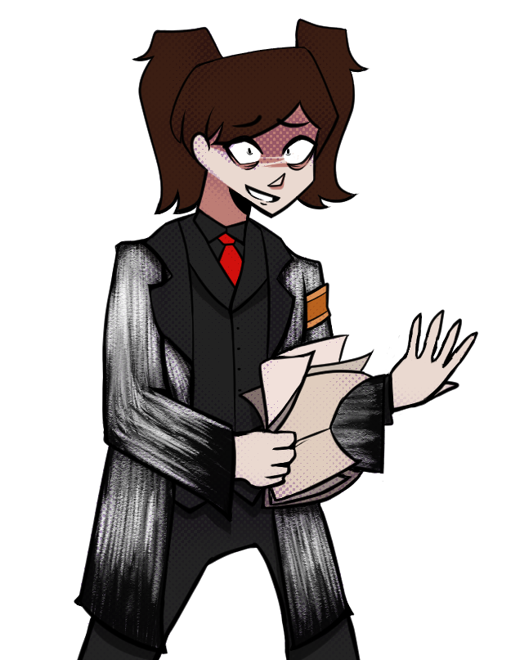

'Sticker Set' (???/113) has been added to your Inventory!

> thanks?

> ew. wipe your hand

She winces.

Her hand sits there where you left it, shaking like a dog; her skin is both peeling at the seams and unbelievably *wet.* A drop of sweat trickles onto the floor. It evaporates upon contact.

> Uh... hello? Who are you?

"**Peewee--**" her voice is hoarse, rasping. Dry. So very, very dry. She swallows and tries again.

"Peewee! I-- I wanted to meet you! Gosh I can't believe it's happening, I--" she sucks in a deep breath, the oppressive heat getting just a shade worse.

*"Peewee I wanted to meet you just once and I knew Camille wouldn't let me but she's not the boss of me at least not anymore because we're all friends and so I KNOW it was bad but I wanted to distract her so we could* ***talk!"*** she gasps it all out in one breath.

She stares at you, hopeful. Desperate. Most likely suffering from heat stroke. "I-- I just wanted to say that I can HELP you, Peewee. Be an-- an ally. A partner. Something more? Scratch that last one." She gets red at that. You can't tell if it's because she's embarrassed she said it, or because of the oppressive heat in this theater. "Just-- just say the word. Say the word and we can end it. I'll set you free! I'll do anything."

Anything?

"Anything you ask."

> Hey Peewee, you have any idea what she's talking about?

You're gonna go ahead and plead the fifth, if it turns out that's actually a thing in this weird universe. APPARENTLY there's people monitoring your thoughts! Who can hack you at will!

She's waiting for you to ask and you're afraid if you say ANYTHING the jig will already be up. As much as it galls you, you have to rely on the Observers to say something the CFO couldn't possibly predict.

> hey, no clip to the center of the earth. it'll be funny

> make us... a pizza

You glow faintly green as you use every once of **Doom** within you to resist the Rules puppetting you long enough to find something you can use.... You're going to pay for this later.

If there *is* a later.

> Can you shortcircuit our hackbrain with sweat perchance?

She scratches at her peeling, sopping skin absently. "I'm not really a hacker, but it's not circuits that are the problem. It's- it's-- it's the THREADS, Peewee! " She's pacing in front of you, temperature steadily rising. Smoke is rising from her mouth, threatening to set your skin aflame. "The threads are BINDING you, and, and-- you should be free, and beautiful, and destructive, just like you're meant to be... and I can burn all those strings away. I can see it now. See it in you. "

She meets your eyes. The smoke burns through your nostrils. "Be free."

And everything goes black.

> PEEWEE BE FREE

> Oh boy, I think everything's black because we've been disconnected and we can't see what's happening.

> uh oh.

> hello?

> A light burnt out, where will we find a new flame of life to play with?

Be free Peewee. Be yourself. You no longer have to cater to your streamer audience.

> welp i don't know what happened there. everything good?

> (apologies if everything is Obviously Terrible, i haven't caught up to this so i have 0 context)

Your mind [bifurcates](http://farragofiction.com/Arm2/) like your horns. Splitting in two. Both there and here. Both free and chained.

As the blade enters your chest the only thing you know, the only thing you CAN know is...

> Reset The Loop

In front of you are a total of 7 beasts.

1. the smallest of them, its head is especially bulbous.
2. this one has very large, very shiny teeth
3. this one is ...wearing seaweed as a hat?
4. this one is monotonously chewing on a chocolate bar
5. this one's head lumps go down its neck
6. this one appears to have rolled in some feathers
7. this one is a fractaling nightmare

You are holding a Pistol with 7 Bullets.

Near the Beasts, you see an inkbot with a note next to it.



When you examine further...

You guess that one Observer wasn't kidding about their Relevance Quotient. Your GAMER INSTINCTS let you know that you can use this item before killing a BEAST... though you aren't a fan of what it did to you last time..

ERROR: RESOURCES NOT FOUND! STARTING IN SAFE MODE.

> safe mode?

You guess everything is more pixelated? Like the textures are flat? Huh. Were those beasts always sheep?

They all look identical now, too. With little hovering alt text describing them...

1. 1972: Echidna
2. 1982: The Neighbors Political Career
3. 1985: Eyedol Moving Countries
4. 1994: Chocolate Guy
5. 1996: Eyekiller Trial
6. 2012: Wanda's G-Fuel
7. 2022: End of the Line

You see a few shimmering protosheep as well, but they don't have labels.

> examine protosheep

> befriend a protosheep. idk why but i just feel it

Your pixelated hand just goes through the hologram of a protosheep, but in your heart, you declare it to be your friend.

> peewee how are you feeling

A little dizzy after the bifurcation.

> Are the threads still there?

You don't want to talk about it.

> is the Closer still here? what does she look like?

She hasn't been here since she lead you to this new pre-spawn point in the first place... Maybe you could go looking for her once you spawn?

> drink the ink

Look fine, okay. The threads are back but its early enough loop you have enough **Doom** left in you to resist stupid commands like this one.

> that ink is powerful so let's test HOW powerful. draw a g-fuel egg on your shirt so you don't have to worry about it later

....You like this idea WAY more than the whole eye thing. You aren't letting that ink ANYWHERE near your body, though, so draw your best attempt at a gfuel egg on the ground.

A glowing GFUEL egg pops right up as the ink disappears. It looks right...but... Something about it feels wrong? Too small? like a GFUEL egg for ants, but in vibes only.

You suspect that a native of this universe could use it to delve into a child universe, if they had any. Sadly, doomed timelines like this one are infertile.

Either way, kinda useless for you.

> Why do I hear doom music?

Probably no reason.

> how much ink remains?

None, looks like its a one use item.

> YOU. EXIT TO 2022

Its not like things went TERRIBLY last time, maybe if you try just once more you'll get even further? You shoot the last sheep.

## **2022 March 30th: 9:00 am**

The pervading feeling of Doom settles into your bones. You will not need Gamer Fuel or eggs, your time here has an extremely hard limit that is rapidly approaching. You have all of today, and all of tomorrow till Midnight to learn what you can.

You are standing out side a grey box, and smaller grey boxes are moving around with seeming purpose.

> look around

The area around you, mildly put, looks pretty fucked.

The first thing you noticed is that the ERROR: LOCATION NOT FOUND is... well, it isn't there. Everything as far as you can see-- buildings, seats-- is some kind of anomalous white box, devoid of any characteristics or descriptors. Some places seem to still have some form... for example, that [LOCATION_CAFE] over there, but something makes you feel like it would disappear entirely if you were to look away.

Even the skybox above you is matte white, with no clouds or sun or stars.

> Can you interact with the grey boxes?

[small talk] it says, before returning to its 'walk' down the street.

Uh. You guess so...

Coming towards you are three boxes, these ones notable because they are bright Banana yellow.

> who forgotten to install counter strike source?

> Hello banana?

> Are these our children? Who else would load in banana yellow?

> greet yellow boxes

[RELATION_PEEWEE_ REBELLIOUSREMARK] says the first, [GENERAL_ECOTERRORISM] says the second [RELATION_PEEWEE_ANXIOUSFAWN] says the last as all three move past you and continue down the street.

> NO CLIP TO THE CENTRE OF THE EART

Fuck this shit, you loudly declare as you sink to the center of the earth...down and down...

> Let's clip downwards past this layer into the organs of this enchidna

Down and down you go. You may be getting slower... or faster? Or not moving at all? Being surrounded by this white box material is not doing your understanding of this scene any favors.

You land at TUNNEL_NOT_LOADED? with a slick 'thunk', the white boxes around you exhibiting EARTH_PROPERTY=MUD despite it all. Huh.

> I really hate when the code underpinning reality gets too obvious. It itches. Say, Peewee, do you have console access? can you lookup the session stats and see if there's anyway to get this instance running better? You're a Gamer, surely you understand the principle

You suppose some parts of this universe are... pre-loaded? Your lack of access to the CONSOLE is making understanding how far you've managed to tear this damn ECHIDNA apart rather complex.

You adjust your SENSORS accordingly, to see if it'll help at all. You are currently... no, still in a white box made out of other white boxes. It's best to assume this is some sort of... den? Bear cave? Underground bear cave?

A single BOX sits in the center of the room, glitching in and out of your sphere of perception. It makes the most HORRID SOUND the moment you look at it-- like a hundred dial-up boxes starting up at once-- as if... to get your attention?

""HEY. HEY, IDIOT!" Its shrill 'voice' threatens to override your auditory receptors into something foul. "YOU HAVE A WORKING SYSTEM. RENDER ME."

> Translations say ""HEY. HEY, IDIOT! YOU HAVE A WORKING SYSTEM. RENDER ME."

> render

> (pulls up wingdings translator) ah, yeah, they definitely want attention, though they're a bit rude about it. say hello to maybe-Gaster?

You wince as your CYBERNETICS jolt up and run hot. A daze runs through you with the sudden theft of your mental resources, seeping out of your internal RAM and flowing directly into the box in front of you. Fuck! You'd lose -1 THREADS (the CPU kind) if there was anything even remotely tracking your stats right now. Mostly you just feel like shit.

The box in front you starts to change, splitting into itself as it forms... limbs? Shitty, low-polygon limbs, resembling more a parody of a man than anything else. What's standing in front of you now is entirely alien, made of boxes and bits, watching you intently with a red eye at the end of its gun for an arm-- that which it is pointing directly at you, by the way.

"FUCKING FINALLY. I WAS GETTING SICK OF MY CONCEPTUAL CORE BEING BOGGED DOWN BY ALL THIS NOTHING. HARD TO ENJOY MARATHONING ONE PIECE WHEN YOU CAN'T SEE ANYTHING." It shifts in place, 'stretching', as far as you can tell. "WHAT DO YOU WANT."

Sure. You'll evaluate which of these AMBIGUOUS BOX OBJECTS you'd like to sit on.

> ask how the hell the box thing stole your cpu

"YOU HAD IT. I TOOK IT. WHAT ARE YOU, STUPID? I SURE HOPE YOU'RE NOT. I'M NOT SADDLING ALL MY FUCKING HOPES AND DREAMS ON A FELLOW ISEKAI PLAYER WITH NO BRAINS."

Ah. Very well then.

> Maybe don't risk sitting on an ambiguous box object. Don't know if it would apply any negative debuff if you sit on like, a spike or something.

You agree! This place seems cluttered as fuck, even for a room full of UNIDENTIFIED OBJECTS. You're only marginally sure some of them are sticking to you.

> hang on, "fellow" isekai player? is it possible this is one of your coplayers from OUTSIDE the echidna? verify this poorly-rendered person's identity this could be really important

You don't get to have eight entire lifetimes from birth on and still care about the sanctity of life and friendship.

You still ask them, though. Another outside player could be... interesting, at least-- that, and this asshole is currently hogging all of your CPU spoons.

"UH, PROBABLY NOT. NEVER SEEN YOUR MUG IN MY LIFE. OR MAYBE I HAVE." It shrugs. "I'VE BEEN PLACES."

> ask the mysterious glitching box how to destroy the universe

The freaky gun-robot-thing lays down on the [OBJECT_FURNITURE_COUCH-LONG], aiming its muzzle at the ceiling.

BOLD TO ASSUME THIS UNIVERSE WOULD GIVE YOU COMPANY. THE ONLY DEATH THAT AWAITS US IS THE CYCLE ANEW.

It screeches out in a language that is screwing up with your mental interface hard. This shit sucks. Why can't the Observers pummel you in a direction that ISN'T the center of the earth, for once? "BEATS ME. IF I KNEW I WOULD BE LONG GONE BY NOW."

> translation: "BOLD TO ASSUME THIS UNIVERSE WOULD GIVE YOU COMPANY. THE ONLY DEATH THAT AWAITS US IS THE CYCLE ANEW."

You're not sure if knowing this makes you feel better. But at least you know?

> Ask if he knows if everyone is seeing the universe like this?

"BETTER QUESTION IS 'IS ANYONE SEEING THE UNIVERSE'. NO. NO ONE'S SEEING THE UNIVERSE. EXCEPT MAYBE MS. CLOSER. I, PERSONALLY, HAVE JUST BEEN WATCHING ANIME WITH NO PERCEPTION OF TIME OR VISUALS OR NOISE. JUST RAW INPUT INTO MY BRAIN. UNTIL NOW. THANKS FOR THAT BY THE WAY.

Thanks for what?

"BOTH THINGS. FUCK YOU FOR BREAKING THE UNIVERSE WITHOUT A HEADS UP. THANKS FOR LETTING ME STEAL YOUR THREADS."

> ask why everything is glitched boxes

The eye at the end of the muzzle gives you the hardest eyeroll you've ever experienced in your life. "BECAUSE OF YOU, YOU FUCKING SNAKE-- SORRY. TOO HARSH. JUST STUPID SNAKE," it corrects itself, for some reason. "TURNS OUT WHEN YOU BREAK THE BONES OF THE UNIVERSE IT TAKES SOME TIME TO FIX. I GET IT THOUGH. HUGE FAN. TAKING THE FIGHT TO THE JAIL OF REALITY. I GET IT."

> ask to watch one piece

You could watch One Piece. You are 100% sure this is considered a 'skip time' thing, though, so you will most likely end up watching 'One Piece' until the world ends. So... up to you, really.

> Before you do or do not binge watch One Piece, could you ask this mystery person's name?

"OH. RIGHT. GUESS I AM USING YOUR BRAIN TO RENDER. CALL ME PARKER." The weird mannequin-thing is staring at the blank box in front of them, which you can only assume is some kind of TV.

> wait wait wait, ask about the closer, why is she watching

> Ask why the Closer would be seeing reality right

"OH. NO. NO ONE IS SEEING REALITY CORRECTLY. BUT SHE'S SEEING WHAT YOU'RE SEEING-- SAME AS I AM. I DON'T KNOW WHY. DON'T REALLY CARE EITHER. IF I HAD TO GUESS IT'S BECAUSE SHE HAS THIS... VIBE OF DISCONNECT. DOESN'T FIT HERE." It shrugs."YOU AREN'T A BOX RIGHT NOW EITHER. MAYBE JUST MOST TOURISTS END UP LIKE THAT."

> ask if it knows where the closer is

"EH. SOMEWHERE MAYBE. I TRY TO STAY UNINVOLVED. RUINS THE ISEKAI OTHERWISE. BUT I ALSO TOOK YOUR THREADS..." It puts its muzzle to its chin in thought as it--

*BANG!!!*

Fuck! You flinch at the sound of a gunshot .WAV that didn't play, but also did, but also never existed. Before you know it, its rifle-arm is pointed at the ceiling, 'smoking' from the shot."THAT DIRECTION. SOME CAFE I THINK. SHE MIGHT ALSO BE DEAD? I DOUBT IT THOUGH." It sits back, relaxing once more at its blank box One Piece. "SOME OF THOSE OLD ONES DON'T DIE VERY EASILY."

> ... did you just use an auto aim hack to find the closer... swag

"SEE? I LIKE YOU. I CAN'T EVER TURN IT OFF AND I MURDER INNOCENTS ON A DAILY BASIS BECAUSE EVERY DATABIT OF MY BODY TELLS ME TO FIRE. BUT YOU UNDERSTAND THAT SOMETIMES IT *IS* PRETTY SWAG."

"NOW COME WATCH ONE PIECE WITH ME OR FUCK OFF WHERE YOU CAME FROM. SORRY. THAT CAME OUT TOO MEAN. WATCH ONE PIECE IF YOU WANT. I'M GONNA BE HERE WAITING UNTIL THE UNIVERSE BLOWS UP OR WE'RE ALL ALLOWED TO HAVE SKIN AGAIN."

> We sort of just fell through the ceiling, and getting the vertical height to clip back up sounds difficult (unless you learned some Sweet Infinite Height Glitch while I was gone), so if there isn't a completely obvious exit, maybe ask if they can point one out?

> go no clip in the direction of that bullet to find the closer

No worries, its time for another **Big Gamer Moment.**

You wedge yourself into the corner of two grey boxes and sort of...shimmy until...yes there you go. The physics engine goes wild and rockets you upwards in an ecstasy of clang and glitch, not releasing you until you finally aren't improperly intersecting with the ground anymore.

Unfortunately, this means you have built up quite a bit of momentum when you finally reach air and find yourself overshooting by a bit.

You hit the ground with a meaty slap and just lay there for a few moments appreciating just how glad you are that you won't have to really deal with the weeks of bruises you just developed.

"Ah. Peewee." a voice says from behind you, sounding strained.

> have a look

> look behind you

> turn around and brace yourself for more CPU lending (and maybe see if you can spawn a party hat while the world is so buggy? it would make this Observer happy on their birthday but no pressure if the system is too messed up to pull it off, everything is so blocky and ambiguous I'm sure I can pretend a bunch of cubes are balloons and such with enough imagination)

> is that the closer?

> that was epic, 10/10. but also, are you ok there?

You remain stunned on the ground for several additional minutes just letting the commands roll in.

> If you can get up after that very impressive launch into space, I would suggest you get up and greet them.

Finally, you get yourself upright and go to greet whoever it is who is talking to you all normal like.

> "Hey vaguely ominous box"

Blinking, you realize they aren't boxes at all. It's...hmmm. Was her name Slaughter? And that shimmering wall of static that seems to be in the shape of... the Closer? Except there's a giant hole in the chest. That's weird. Both seem to be keeping their distance from you.

"Hello, Peewee..." Doctor Slaughter says, evenly. The Closer is saying nothing, just watching your every movement.

> just for the record, we absolutely did not ask that guy to shoot you, nor did we have any idea that he would or *could* before he did

> ohhhhhh ouch. "Doc I know your field is psychology (psychiatry?) but do you know anything about treating gunshot wounds? we were just trying to FIND miss Closer, not uh... do that."

> that's at lot of damage

Evenly, not taking her eyes off you, the Doc slowly responds. "I'm not sure such a wound COULD be treated, to be frank. This...unusual state of the world appears to preclude first aid. But thank you, for letting us know you are not to blame for the attack. I will make sure to work with Parker on appropriate boundaries. "

The Closer, meanwhile, is glaring at you, somehow perfectly unreadable on the emotion. It may be because she's been comically shot. "Oh, I assure you that this will very much *solve itself.* If only one could curve the proclivity of those circus acts to use their heads before..." she trails off, static shifting.

The Doc sighs, then turns to you "Peewee, we were just discussing why the Universe might be in such a state. Did you have any hypothesis of your own?".

> possibly. what's it worth to you? we didn't try to kill you but we're also not exactly friends...

The Closer makes a sound best described as a muffled scream as Doc Slaughter raises her hands placatingly. "Fine, fine, we're not friends. So why are you here then, Peewee?"

> Ok, beyond showing off Sweet Gamer Tricks, I have sort of lost the plot on this one. Reading back, apparently Closer like, actually sees sort of what messed up stuff we're seeing now? And also she can say more than our kids can right now. Which is simultaneously 'depressing' and 'ok at least we aren't ALONE in this mess.' I will leave it to you to fill in anything else. Oh, also, if whatever was probably sticking to us earlier is ever was and more importantly still sticking, hold onto it for when stuff is normal. It is too messed up to see what it is, but you know what sticky object we may be concerned with obtaining. Worst case scenario you can just toss it if it isn't worthwhile.

> Was that prompt I just sent too long? Just in case, important part: shit hit the fan but it seemed like closer was still, like, kinda normalish compared to 'minecraft irl', and also you were right above us so we did a cool gamer trick and now bam here we are.

> Also trying to figure out what's happening. Maybe we can trade info?

Doc Slaughter starts to answer when the Closer throws a staticky arm in front of her. "Oh, no. I do not think we will be trading anything. Peewee, you seem to be under the laughably mistaken assumption that this is a negotiation between equal parties."

She pulls out a familiar contract.

# **Installment Promissory Note:**

**Date:**Maze, Loop 190, Arm 1

For value received, Peewee Cassan (The "Borrower") promises to pay to the Order of The Closer * (the "Lender") the sum of three (3) favors of greater or equal value to $183,846.43 US Dollars as agreed upon by the parties involved or third party arbitration (if requested by either party). Interest on these favors shall accrue at the rate of one additional favor per two loops wherein any original favors remain uncollected.

### **THE TERMS OF PAYMENT**

1. Payments: The unpaid favors and accrued interest shall be payable at the sole discretion and pleasure of the Lender.
2. Application of Payments: All Payments on this note shall first be applied to accrued interest and any reminder in payment of principal.
3. Termination of Payment: In the Event that the Borrower or the Lender dies, no discharge of obligation will occur.

*Note: All NAMELESS Individuals shall be referred to herein as if they were legally named.

Her staticky frame may be faceless, but you get the distinct sense of a predatory smile. "I seem to recall you owe me quite a few favors, now don't you, Peewee? I think I shall call one in. Tell us what you know, and you get nothing in return. "

> we get the second of three favors discharged. that is not nothing.

> Respond: "Then you are going to need to put forward that request through a legal representative. The current construction of the contract is being reviewed as potentially invalid by our internal legal representative team, so we will not willingly be paying the favor at this time."

> accuse the contract

>guess we follow along? idk what we're supposed to know but you know, right? uh.

> give us all a moment here

> try to make the case that you technically die at the end of every loop and as such this contract is no longer binding?

> you know, because death equals no discharge of obligation

> she asked us for what we know, but not what we know about the universe. genie rules, start spitting some gaming facts about skyrim



":) :) :) It SOUNDS like someone is in need of some third party arbitration!!!"

Oh good. It's JR again. Why did you choose them as the third party arbiter again? This can only end in chaos.

"SO! It sounds like the Observers Outside Reality have a variety of arguments for why this contract should be null and void?"

  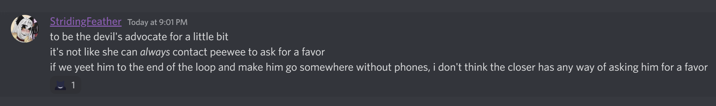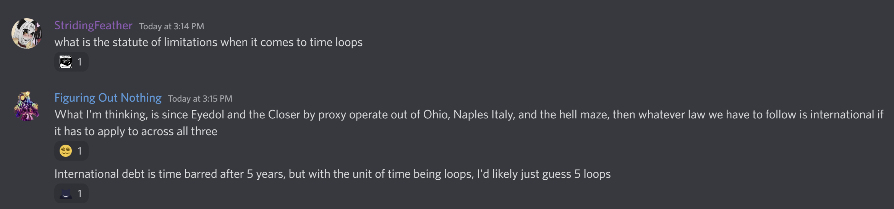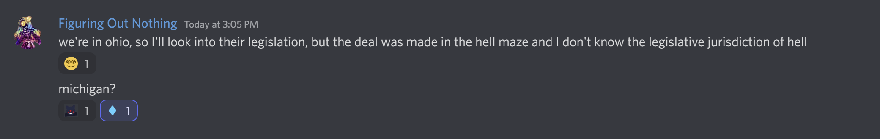 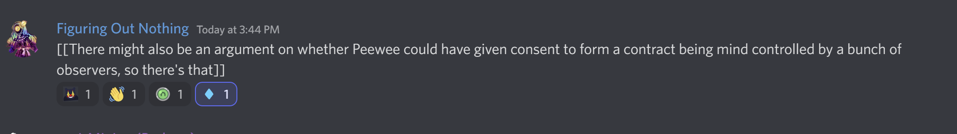

"Hmmmmm well!!! As your Arbiter I happen to agree! Definitely not a fair contract! "

The Spiraling horror taps their 'face' thoughtfully.

"BUT if we're gonna go so far as to argue Peewee can't consent to enter contracts in the first place...well...he'd be stuck in that maze still! And I don't think anyone wants THAT! "

"So tell you what!!! The Closer cannot accrue more than 3 favors TOTAL at a time! And if a favor is OFFERED and REFUSED ya'll can summon me to arbitrate again, ofc. Always could really.

And, to compensate the Closer a bit for her lose, Peewee will be guaranteed to not be present next loop. Give her a lil bit of breathing room! "

> I for one, am up for it. Question though before I commit: where WOULD Peewee be?

":) :) :)"

And with that the Arbitration is complete. The Simulation restarts, and Doc Slaughter and the Closer are still warily waiting for you to speak.

> ascribe signature to contract

You fail to sign anything as Arbitration is binding. It does not require your permission and does not come with the right to appeal.

> Not sure what happened myself, but tell them that "the universe got bifurcated" and that "a version of you made it to arm2". They'll probably know what that means.

> We've consulted with the arbiter and you should find that the results of this binding arbitration are spelled out in the terms of the contract. We do seem to be obligated to answer. So. Do you know of circumstances around the end of the Loop previous to this one or do we need to explain that?

> can we still tell the closer about skyrim? just for funsies?

The Closer scoffs. "Yes, yes, of course you made it out. My wife made it *extremely* clear to me before the End that you'd slipped your leash."

Doc Slaughter's mouth opens, then closes, then finally opens again. "Forgive me. I'm afraid I'm not quite fully 'in the loop' as it were. Leash?"

> wife?!

The Closer radiates smugness but does not clarify.

> If we're ever going to use Doc Slaughter's services, might as well be honest.

> Leash is probably referring to the fact that Peewee is being puppeted be extra-universal figures.

Doc Slaughter's eyes grow wide and flick to the Closer, who nods. "Oh. My. My condolences, Peewee. The offer for therapy does stand. If you believe it would help."

> This Loop started up with "ERROR: RESOURCES NOT FOUND! STARTING IN SAFE MODE." While this is purely speculative, it seems like your universe doesn't have enough processing power to run two instances of Peewee.

The Doc swallows heavily, eyes focused on the untextured ground. "I. Well. That is. Unfortunate. Are you. Certain. There's two? Still? "

> Updated information on the other Peewee has stopped. Unknown if because he died or our viewing connection disconnected

> Simultaneity is hard to judge when a Lord of Space is brute-forcing something very like a time loop. But from our perspective, yes.

> when did the current conditions begin, from your point of view? that would help prove or disprove the hypothesis

> I mean we can't control Peewee 2 because of some smoking hot babe messing with him but we can still see what he's up to. last we saw he was crawling around under Disney World looking for something to mess with. that and he got stabbed and the CFO won't let him use the console

Doc Slaughter is very very still. "And that's as far as you can See? To him crawling? No more than that?"

> why, Doc? you think we're wrong? got info we don't?

She shifts uncomfortably. "Nothing I can be certain of. ", she admits, distaste clear on her face. "You said there was a ... a Space Loop, was it? " and obvious ploy to change the topic.

She gestures towards her companion, "Ms. Closer said that those new to the Loops can't remember between them. If it were Time, I would presume this to be because there's nothing TO remember, that causality is unwound. " She hesitates. "Yet, I do remember. Forgetting is Simply Not Done for those of my station, back home. Though I can think of no mechanism by which Remembering could be held despite causality. Which, when combined with your thesis on looping space... has some Unsettling Implications. "

> We have a recent update. That Peewee is persistently alive, despite physical conditions that should mean otherwise.

> wait no he just got rekt

The Doctor is silent, staring.

> we've more than answered the question that was asked

The Closer sniffs. "Then I'm sure you have no further business here."

> nah, we asked a question that will be helpful for all parties. When did the current low-poly conditions begin, from your point of view? correlating that with our/

> (whoops) our/Peewee's point of view would help to confirm or deny the hypothesis

Doc slaughter seems to relax a bit. "Oh. Certainly. I would say I have several decades of...'memories', yet they ring especially hollow. Apparently I had [INSERT STATSTICALLY LIKELY AMOUNT OF CHILDREN], for example. My memories start actually coming into focus a few minutes before Ms Closer was shot." The Closer glowers at this but seems to be committed to snubbing you.

> ehhh, I don't like this much either, especially since it seems to have sapped all the sentience out of the natives. it's gonna get boring quick. You're still "real," tho.

"Yes. Well. I wish I could ascertain why I have been spared. Ms. Closer explains that she tends to be immune to these sorts of things, but there is no obvious reason I would be."

> Hey Peewee, we tend to railroad over you so much you don't get a word in for yourself. What's your thoughts on all this?

You do not want to think about that.

> Maybe not with you Closer, but with the Doc maybe. I was actually wondering if we can do a therapy session today. Given the chaotic nature of those controlling Peewee, we can't really be sure if he'd be awake or even alive for any length of time so scheduling isn't viable typically.

Doc Slaughter blinks. "Certainly, I can say with some degree of confidence my schedule is wide open. If. You're sure it's safe?" at this she's turning to her companion.

The Closer's eyes narrow. "No. Don't be absurd. That *creature* is not to be trusted near *anyone* alone. Especially not now." She uses a staticky hair tendril to rummage around in a bag she's brought. From it she brings out a small grey box, labeled by the program of the universe as [OBJECT_WEEB_FIGURINE=HATSUNE_MIKU_2006]".

"I presume that my presence would not be welcome during your mental health treatment, Peewee. As a counteroffer, I hope we're aware that the Shot is, plainly put, erratic," she says, the bullet in her faux-chest apparent, "but he will not particularly care to listen in, yet will assure the safety of my Client. Take it or leave it, Peewee. No therapy. Or Therapy with the semi-privacy of that hole person serving as a body guard."

> That deal seems fine.

> seems reasonable. to assure you of our fair dealings - Doc's answer actually throws doubt on the hypothesis that Peewee's mere presence is causing the system drain, in at least this Observer's mind. We used the Maze spawns to come straight here; Peewee was not present for the time between whenever the Maze is and now. In fact, it sounds like his presence INCREASED the processing availability.

> I mean, it's your therapy, even if we sort of forced you into this conversation about having it. What would you like?

That deal seems fine.

> Quick question, what do we look like to you guys right now. Since we're seeing things different, I'm assuming you guys are too

Doc takes the lead on replying while the Closer is waiting for Parker to get here the long way. "Oh. Well, you have a lot less eyes than when we last met? Less resolution as well, but I imagine we do as well." She hesitates. "It's just. Well. You pose a risk even beyond what those Native to this Universe might. I'm... given to understand you seek to destroy it?"

> Well this Peewee's free will is pretty restrained so here he doesn't pose the universe harm. The other one though...

> peewee does, most of the observers don't. usually just kinda cancels out into getting humiliated and/or killed in various ways

The Doctor mulls this over a bit. "That leash you mentioned. Yes. I think an emergency therapy session is quite in order."

> any chance you can get the Flower Lady/Eyedol CTO to cut herself out of the listening circuit for the duration of the therapy session? there is NO way Peewee will be willing to engage with the process while she's listening.

The Closer has gone very, very still. "No. You do not get to make demands of my wife."

Doc Slaughter raises a hand in a placating motion. "Ms. Closer... Forgive me if I am making assumptions but. I do not believe anyone in this world, save ourselves and Parker truly exist, currently? It follow's that Peewee's request is a given."