Saved On: 4/1/2022 11:36:37 PM
It's so crazy that I got into Zampanio just in time to celebrate such a huge milestone.

> JR: explain the concept
Gimme a sec...
> JR: so the way i figure
>JR : rather than us all being anon
>JR: we can include our Title or whatever
>JR: tho me and IC will stay initials
>JR: im headed to bed tho
>JR: so
>JR: update in the morning
>JR: and we'll search for zampanio together
> why is the window so small
JR: haha whoops, messed up the styling, fixed that now
> attempts shall be made
>JR: If you've got a title, label yourself yeah? like
>Waste: this
>JR: except JR is always JR
> that's better
>JR: hell yes :) :) :)
> i guess i'll give an answer for the title labeling
> Answer: answer
> weaver: ooh sounds fun
> What is happening
> Huh
> Awooga
Начало
Catalyst: so do I just write my title in front of every message? oh god people will totally not misuse it
return to sburbsim
JR: what could POSSIBLY go wrong, you're right Catalyst
JR: Anyways SBURBSim doesn't exist one day a year. Welcome to the future.
JR: ANYWAYS IC is awake so we're starting once we're done playing with the tumblr april fools
> JR: I will now be giving out 50 twitch subs
IC: You know what I like this one better. @JR confirm?
> JR: lol glad to see the Unmarked and Titled already understand the point of this chaos
> JR: do i even still HAVE a twitch stream?
> JR: ANYWAYS, to the wayback machine
> JR: so the point of this is when we made the knucklesux blog WAY back when parts of it were sourced from various old geocities or whatever pages, which is how we got exposed originally to zampanio
JR: so we're hoping to find an actual copy now that we want to play it instead of just not realizing what we were seeing
> JR: whoever finds the game first will receive a personal explanation of the Eye Killer's backstory :) :) :)
>JR : yup thats totally me, but you KNOW WHAT why not. yall solve hte puzzle of today and i'll answer THREE questions perfectly honestly about the Eye Killer and/or ask IC and hope IC answers honestly. 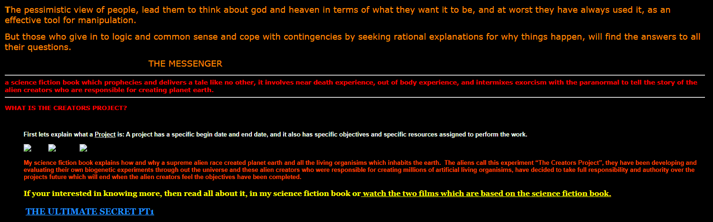
>JR: its beautiful
> Catalyst: alright, so how do we look through knucklesux's sources on the wayback machine?
>JR: i have no idea! but we're gonna try. google is our friend for now
> IC: You technically can't, half of the websites don't even exist anymore. I think some of them do? But I can't remember the search engine we used to find them...
JR: shit you're right

> JR: i can't even find that conspiracy theory about echidnas secretly being reptiles
> Catalyst: well the obvious isn't helpful, unsurprisingly 
> JR: it had LITERALLY never occured to me that like. google can't find things in the wayback machine
>JR: really adds to the experience of Old Internet that you can't find shit
> JR: this whole time i just thought that if i put my MIND to it i could re-find zampanio, easy
> Catalyst: lmao 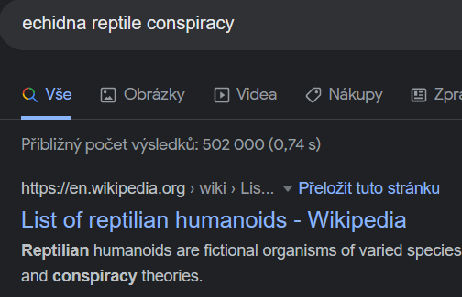
>JR: i meaaaaaaan.....not NOT what i was thinking of
>JR: this is just the cheetoh timeline all over again
> Well the greek Echidna is mentioned among reptilian people, also found a shitty creepypasta about a reptilian with echidna spikes
IC: I feel like you can find a lot of creepypastas about reptilians with echidna spikes if you put your mind to it. I don't think it brings us closer to Zampanio though.
JR: holy shit i found something, one sec
IC: Oh lmao you're right, check this shit out:
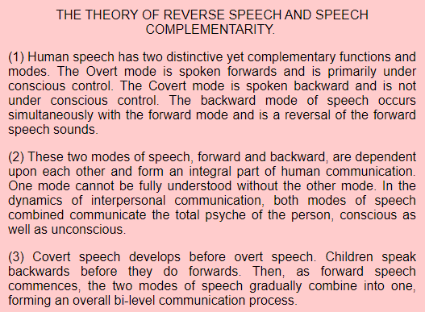
IC: Children.... speak in reverse?? The website is CHOCKFUL of children's recordings where they allege they're saying something backwards. I'm. This might work? I don't fully BUY it but we might find Zampanio if we start thinking a little bit more creatively I guess.
> JR: I think i found the first breadcrumb we had to zampanio
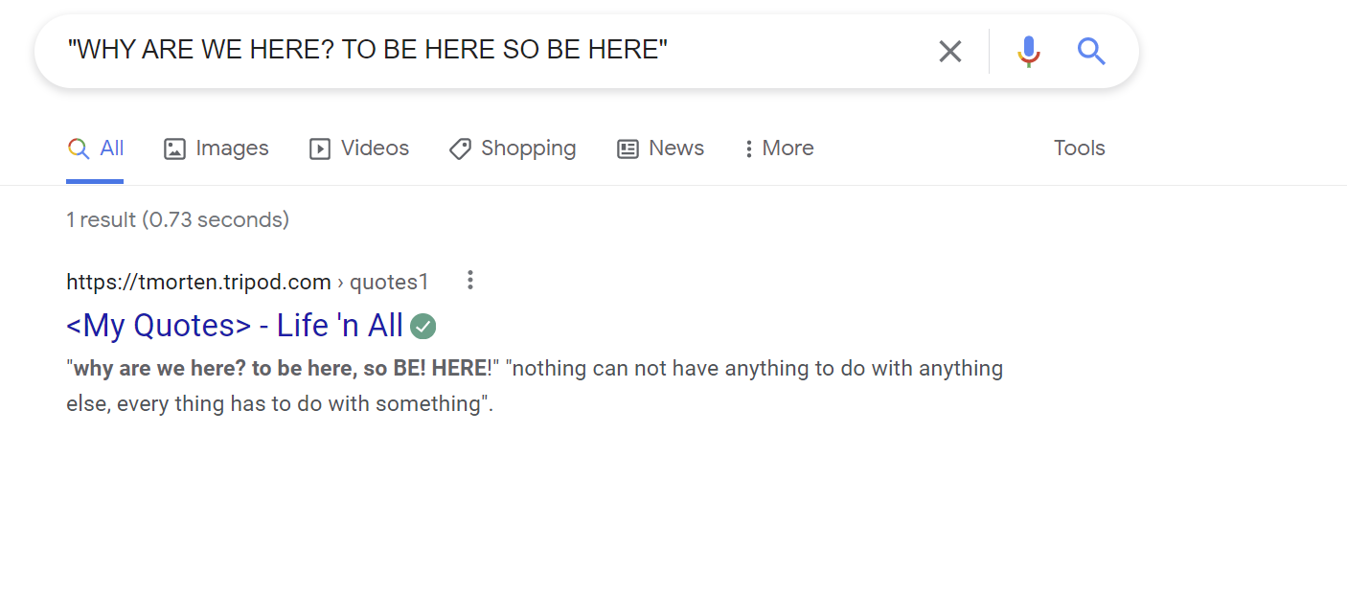
>JR: i...
>JR: yeah i think this was one of the actual breadcrumbs we found
>JR: i...just..full of zampanio quotes
> JR: this is LITERALLY where i got the idea for East from
> present your lawyers badge
>JR: lol we're not in that universe rn
> Catalyst: holy shit nice
> IC: Just remembered we still had wiby, looking through some of those pages there now.
JR: oh shit yes, look up carol shaw, i remember she was involved in zampanio
> Catalyst: uhhhh tried to look up the site and https://tmorten.tripod.com/
JR: isn't it wild, Catalyst?
JR: such a vibe
> Unmarked: What a lovely collection of webpages!
>JR: who's this? do you not have a Title?
> IC: Nothing on Carol Shaw, except for like, a couple of atari documents that didn't lead anywhere, I could find her coworkers?
>JR: eh, nah, we're cool, it was just a breadcrumb i remembered
> Unmarked: remember to bookmark this! (I don't think I hav3 a titl3?)
JR: Ah, the Forsaken? Well, not anymore. Only Forsaken if NAM is ignoring you.
> Catalyst: oh it's totally wild, there's a quote about a yard stick and an infinite spiral on the same page 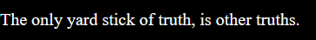
>JR: and you WONDER why i got so enthralled by zampanio, with horseshoes like that
> KR: oh man, not this shit again. I don't think it's healthy how much you've been obsessing over this game.... but fine. April fool's is your *thing*, so... maybe try https://theoldnet.com/
JR: !!!
JR: thank you for this gift KR
JR: and look
JR: obsession is in the Eye of the Beholder
> JR: HOLY SHIT I THINK I FOUND EARLY ZAMPANIO DEV NOTES???
okay okay okay so IC found THIS from a carol shaw fan site
apparently there are some lost game files from the first game she ever made (1978 not 72 so clearly she didn't make zampanio)
but LOOK at this and tell me its not a fan zampanio game
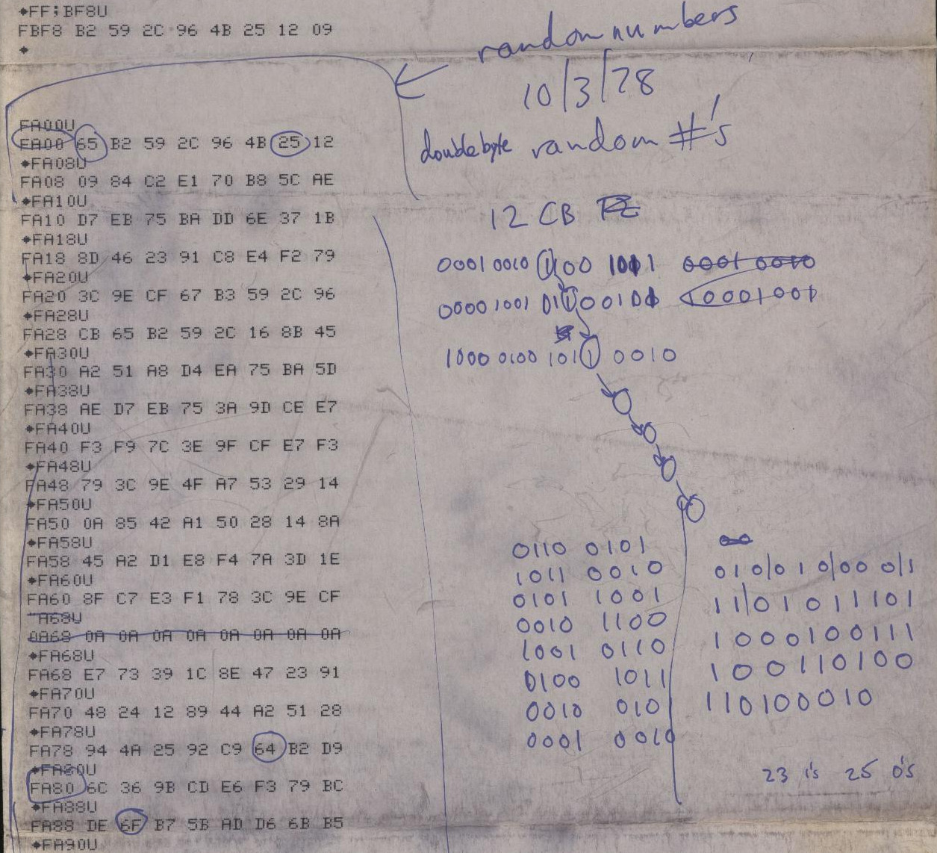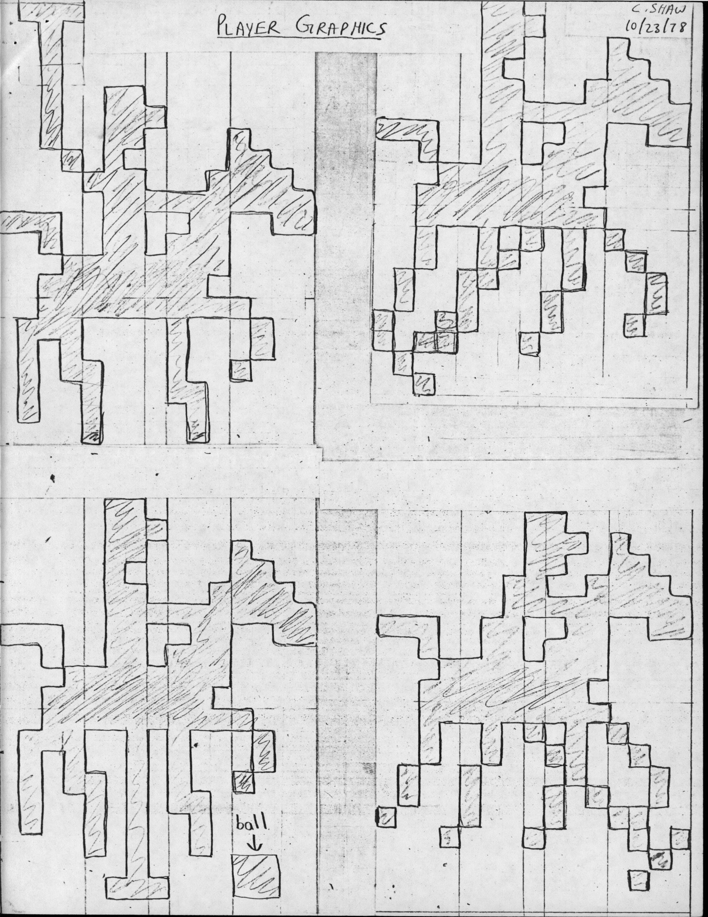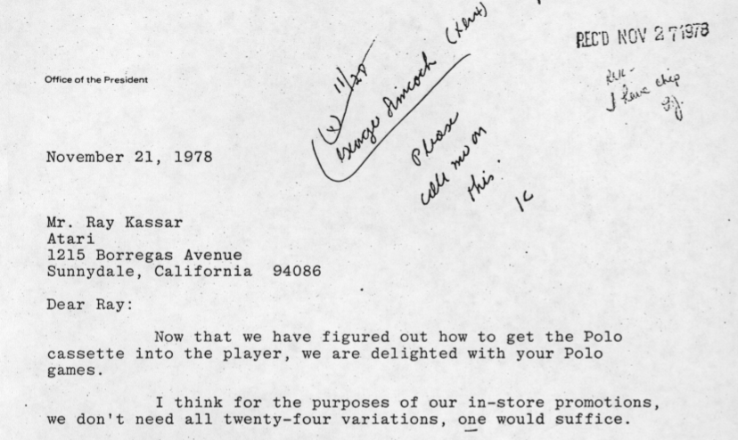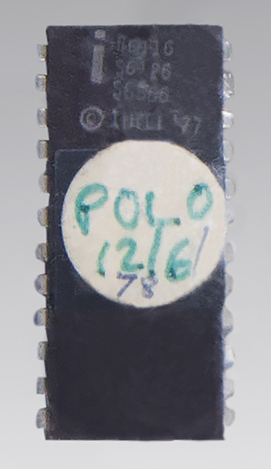
> IC: I don't know about you JR but I'm pretty convinced.

> Catalyst: wdym I've been worshipping devil yoda for decades
>JR: lol
> JR: whoops, no that Unmarked isn't the Forsaken, confused their quirk with someone else
> IC: Geez, it's been so long since I've looked at the timecube guy
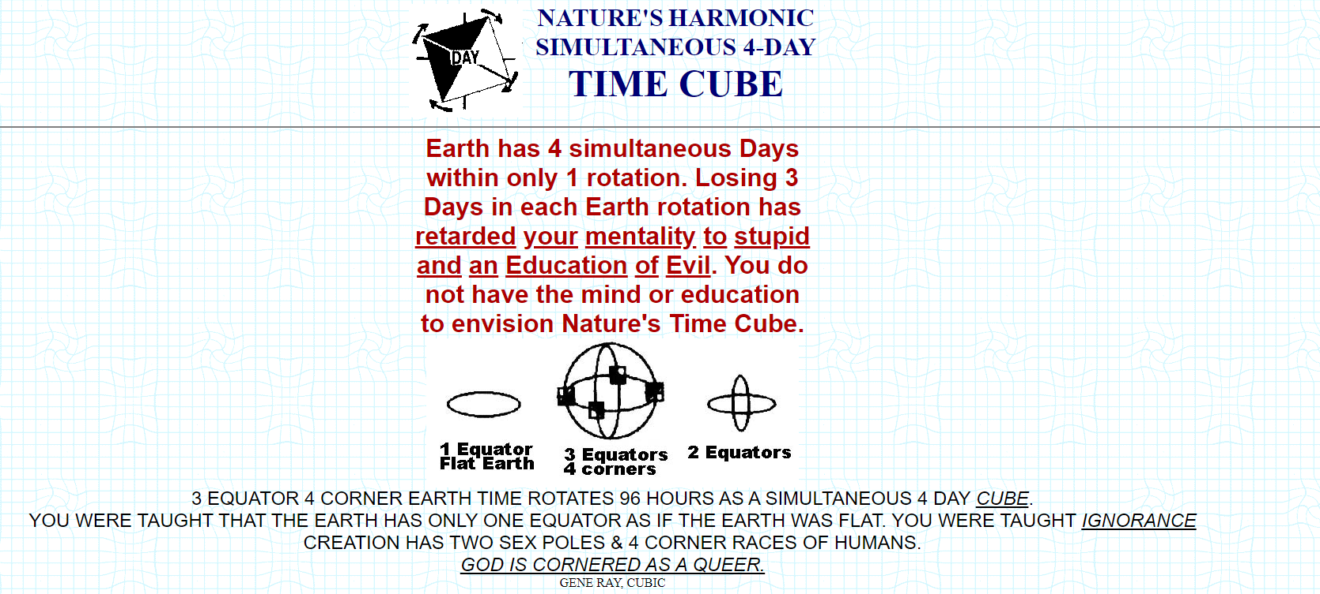
>JR: I met the time cube guy once, in college. he came to give a talk
> Ай
>JR rip all i can do is google translate that. i wonder if AW can read it
> JR: thanks i hate it
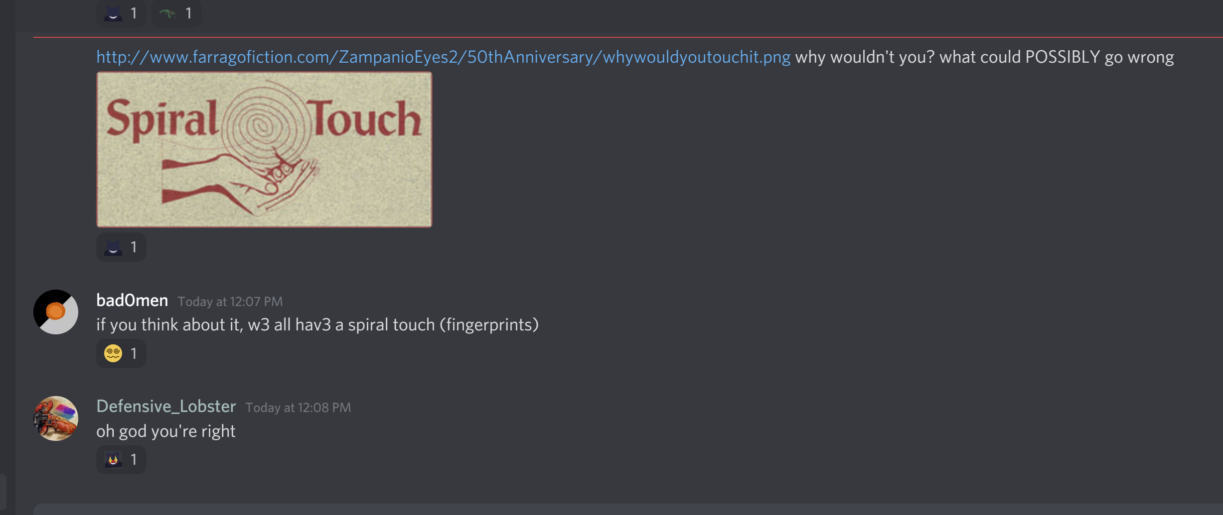
> JR: also i appreciate that this is a new way ppl off the discord might find the Eyes
>JR: oh god i remember this
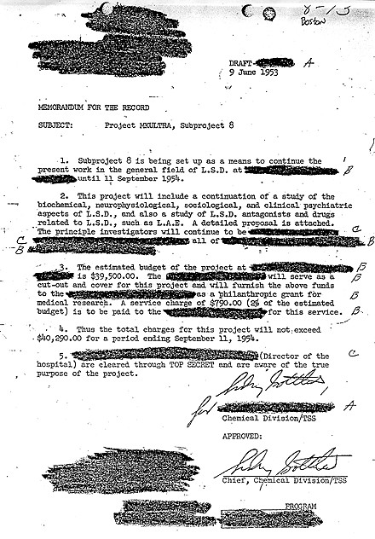
>JR: it was part of the aluminum foil conspiracy google group i found
>JR: i think a member of the Reynolds family funded the project?
> Catalyst: yea the Reynolds are mentioned a few times on knucklesux
>JR: as a mind player anything mind related is gonna get my attention
>JR: and now that wanda is the writer of the blog (and obviously always was) its even more true
>JR: well. not JUST wanda
> JR: cuz wanda wasn't hte one to steal my damn grist card
>JR: but thats neither here nor there
>But YEAH yall at least found the echidna conspiracy so i will gift you one of three (3) true facts about the Eye Killer. Ask away.
> Catalyst: do we have time to prepare the question(s)?
>JR: well first one to ask gets answered so you have as much time as it takes some random Unmarked to beat you
> JR: meanwhile i think IC found someone elses take on truth

> Catalyst: lowkey looks like paldemic
>JR: oh shit you're right
> Unmarked: reminds m3 of google chrome tbh
>JR: the horrorterror google seeps in everywhere
> Catalyst: looks a bit like the aperture science logo too
>JR: oooo you're ALSO right. so many ways you can have no-quite-spirals
> Catalyst: alright, we agreed on a question Oh Mighty Dungeon Masters. What is the relation between Piper Rusting, Eye Killer, and L-C-002?
>JR: long story short, piper rusting, like so many others, got lost to obession and ended up in zampanio. once in zampanio, its pretty easy find yourself sanded down in some ways and sharpened to an edge in others by the loops. there is monstrousness in repetition.
>JR: wait. shit. i was TRYING to be direct there but it came out weird. i'm not even doing a bit. IC, can you take a stab at it?
> IC: Take a Stab at it.
IC: You got it boss.
IC: Short story long: What relation do you have to a version of you that was never born? Piper Rusting never existed, not really. The metamorphosis that needed to happen for her to exist cannot in the vastness of this stupid Echidna. JR disagrees with me sometimes about this so it's a bit of a Schrodinger's Character, but you can take either of our words for it. I won't feel sad about it.
IC: As for the other two, the Eye Killer and L-C-002 are the same concept, at least in the End's eyes. It's up to you if you decide to trust her on it.
IC: Oh right, btw, JR wanted me to tell you: If we are to use Piper Rusting more liberally (say, the concept of the Innocent, which is what you know): Then yes, they're all the same person. Time clones are weird. But she also wouldn't technically go by Piper Rusting, because of what I mentioned before...
IC: But that's both spoilers for 5Darps. Imagine getting spoiled on a niche TTRPG stream by some random ARG? TL;DR: Time player shenanigans, not heart player shenanigans, and you'll connect it a lot easier.
> JR: look i'm just saying that The Innocent is a hell of a lot closer to Piper Rusting than The Eye Killer. but I'm ALSO saying that yes i get that "Piper Rusting'" is a fake person even on a good day
IC: “Piper Rusting Was Never Real” is a plot beat so fucking devastating in 5Darps that it recontextualizes shit up to like, episode 20-something? Oh yeah, sorry Catalyst. That also potentially spoiled you for shit that hasn’t even DROPPED yet, so y’know, enjoy your forbidden knowledge I guess.
>JR: lol
> Herald: i just woke up what's going on
IC: Lore, maybe. Also finding Zampanio fanwork.
>JR: we think Carol Shaw, an early female atari dev made a zampanio fan work called Polo, its so great
> let me read my sburbsim session
>JR: lol, theres nothing i can do. sburbsim is set up to autoredirect on april first and theres not a forth on earth that can stop it anymore. so we just treat it as a holiday whenever it hits. its been like this for...five years now? i just hack what 'lifesim' is for a day so it points to something new at least
> Taxonomist: hey, local cryptid here
>JR: hype hype hype, let us know if you find any old references to zampanio. we've been searching wayback and a few others
> Taxonomist: on it (sounds of typing on many keyboards can be heard)
IC: Cool. I love keyboards.
> JR: wait wait wait IC can we talk more about the time shennanigans
IC: Okay. Do you mean about the fact that they are all literally the same person, and the Innocent exists because of literal Time Shenanigans? The fact that the whole timeloop is actually a literal timeloop? The stuff with past/future Wanda and Closer simultaneously existing?
IC: Do you even know how little that narrows it down?
IC:> Catalyst: hello EC and herald! Also GOD FUCKING DAMMIT IC. I mean, I was getting sus vibes from Piper already, so this isn't a completely unexpected plottwist, but GODDAMMIT
IC: get apollo'd lol
> FUCK OFF AND LET ME READ MY SBURBSIM
IC: LOL we literally can't. When JR says "there is no way to do so" she absolutely means it. This April Fools debacle has existed for longer than you or I. You're just gonna have to live with it.
IC: I guess if you're desperate enough, the Javascript version still works lmao. Relic of an old time.
> Herald: just got done backreading and this is fun because i'm actually fixated on the old internet right now (also that eye killer lore??? what have i missed)
IC: A whole bunch. Also the old internet is dope.
> JR: i was a small part of the old internet. every time i see a remnant of my past self its so funny
> ALSO i finally remembered that in 2021 we DID have an april arg. we just never told anyone about it? it actually is related to zampanio in retrospect. we wanted to see if people would try to look
> taxonomist: man I love april fools
>JR: same
>> Oh you know the origin of the Eye killer herald? Yeah we learned a bunch more, and if anybody finds anything interesting on the old internet, we may even earn two more lore dumps
>JR: lore dumps! lore dumps!
> >JR: ALSO by time shennanigans i was trying to say the oxbow lake of The Innocent being the past self of the Eye Killer and ALSO not at all anymore. The Eye Killer makes sure of it.
> IC: Oh yeah, before I back off for a bit:
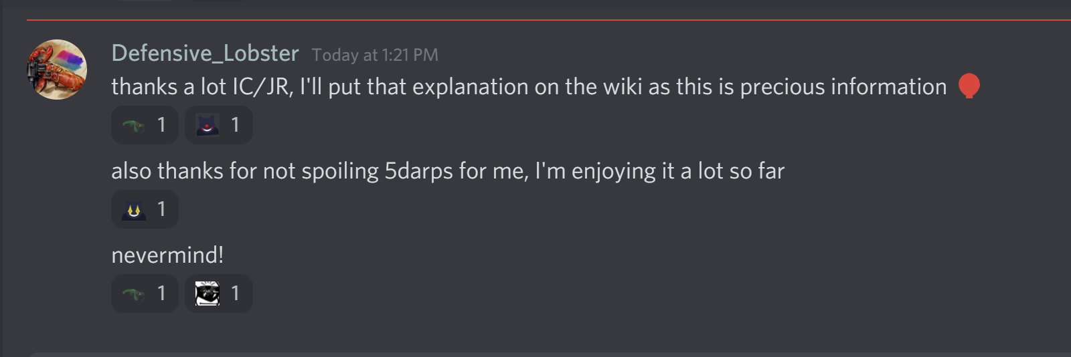
IC: I don't think you understand. By engaging with Zampanio, you were being spoiled for 5Darps. I gave free reign to JR on a lot of my characters from there for fun, and at the rate that this was going, it was going to come up here first.
IC: If it makes you feel better though, a lot of stuff about Piper 1. I don't know about and 2. Can't come out here, because of JR's naming system and also because the Eye Killer is a different character, or 3. Could be retconned at any moment. So, really, you're about aware as every other player was at the time.
IC: I think being spoiled for it makes it a lot more interesting than if you aren't tbh. You'll see why when you get to it.
> JR: run this show solo for a few hours
JR: just me for a lil bit, i'll make sure to post anything yall find related to old links to zampanio or even just fan works of it, and i'll be looking myself as well
> Catalyst: dw the "spoiler" isn't that big of a deal in the first place, and I'm already really interested in the campaign!
JR: yessssssssss
JR: ironically i watched a CHUNK of where NAM 's source is from but none of 5darps
> Unmarked: as someon3 who does not hav3 th3 tim3 to watch 1OO+ hours of yugi-oh roleplay i appreciat3 it
>JR: lolololol
>JR: theres just something so satisfying about '100 hours of yugioh roleplay' being backstory for this
>JR: obsession is a hell of a drug and we must all choose when the price to learn something is not worth the cost
> kinda wondering, are nfts being added in (this is a joke)
>JR: dude, unTitled rando, you don't even KNOW. someone stole dollsim dolls to turn them into NFTs, we had to get a takedown
> dam bro thats a yikes
>JR: nfts are the devil and the fact that Wanda canonically "pre-invents" them is only one of her many, many crimes
> Taxonomist::fear:
> tell me what code makes sburbsim redirect to this so i can lobotomize the website and make it actually function instead of redirecting me to bullshit i have no intrest in
>JR: well since you asked so nicely, be the change you want to see in the world
>JR: good luck getting dart working
> Catalyst: as someone who watched 100+ hours of a dnd podcast before, 100 hours of yu-gi-oh roleplay is right up my alley
>JR: lol happy to oblige
> any opinions on april fools?
>JR: i think april fools is a fun excuse to make things different, just for a day
>JR: to shake things up
>JR: and maybe unearth a few secrets together as friends
> Herald: everything i hear about wanda sounds like a shitpost and when i find out that it actually happened i get whiplash. also that april arg link leads to a 404
JR: wanda is less "lol random" and more "somehow responsible for every lol random thing that ever actually really happened". retroactively.
JR: also, oh shit here lemme help, forgot that repo was private
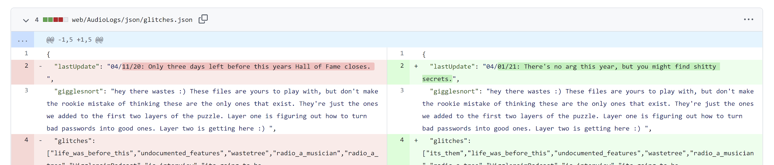
> JR: man finding my past selves path to zampanio is hard
>JR: its hard and you all understand
> Herald: tangential bullshit connection probably but i was thinking about an inside joke from the creatures fandom (late 90s virtual pet/genetics simulator combo) and i'm 90% sure it was a secret zampanio reference: Secret_Adventure_Mode
>JR: oh shit
>JR:yeah that reeks of zampanio
>JR: no way they weren't a fan
> JR: maybe i should just start looking for polybius myths and work backwards from there
> JR: okay so
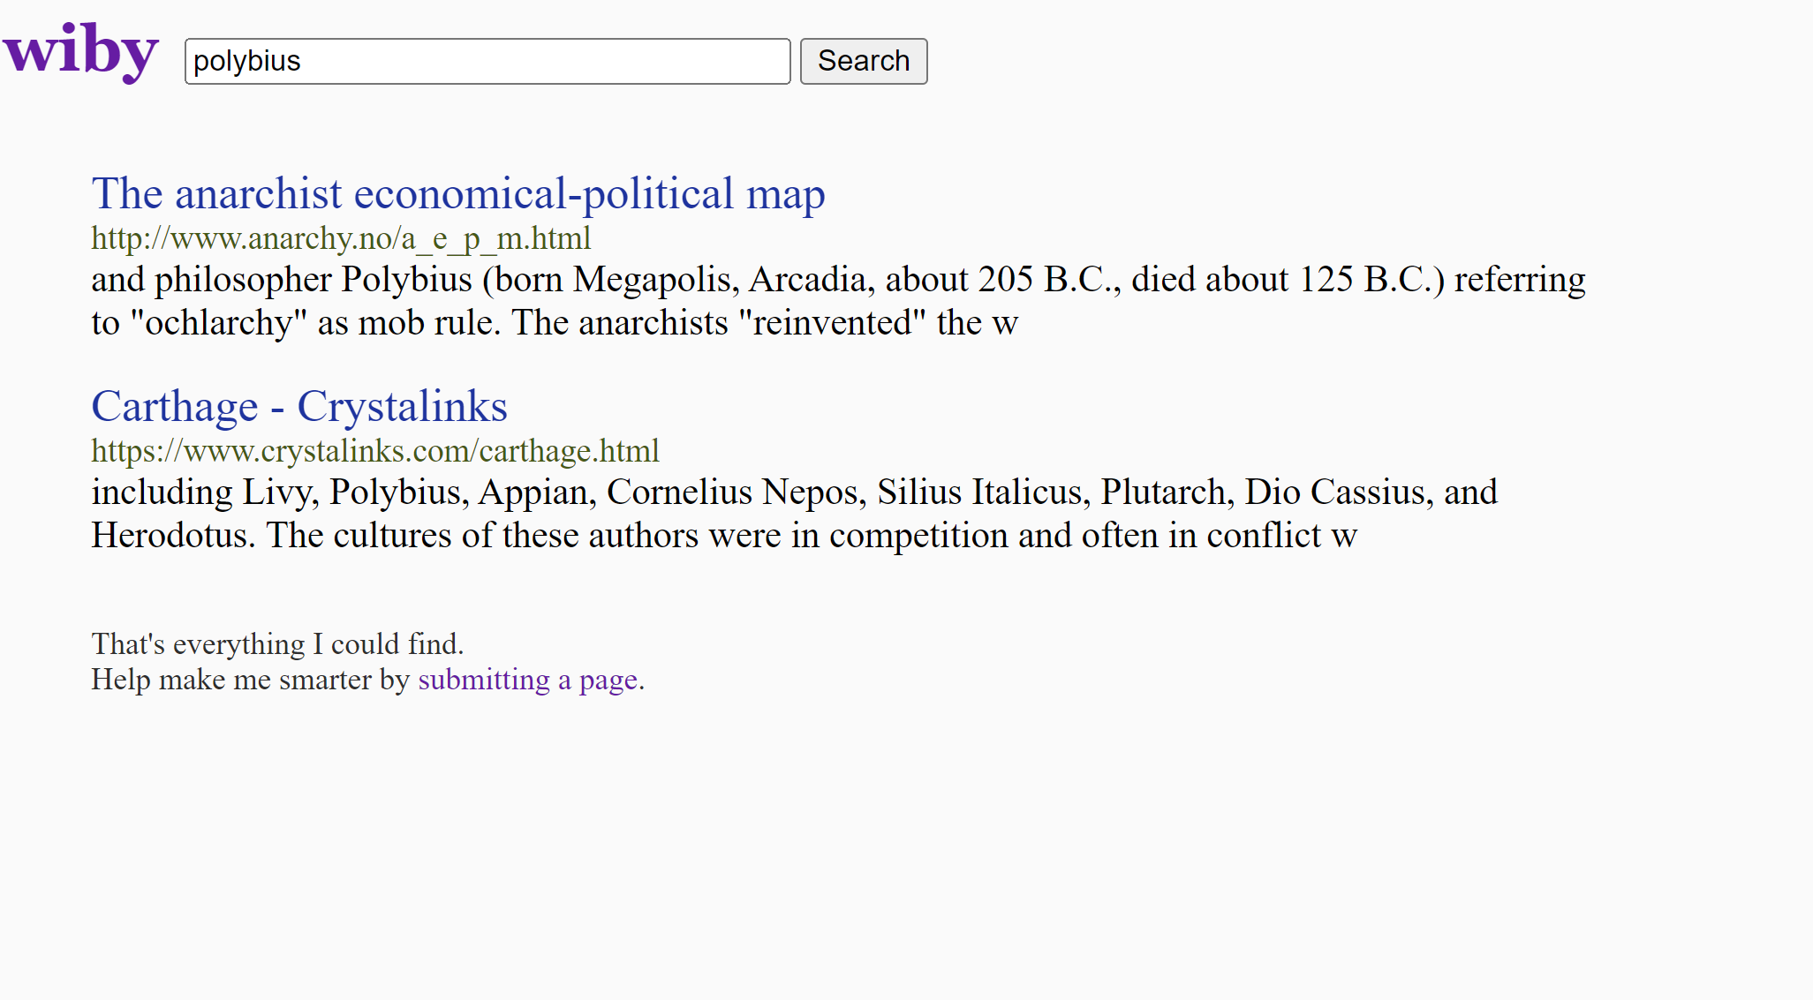
>JR: wibly is so old it apparently predates the Polybius game myth
>JR: just talking about the greek one
>JR: which
>JR: HUGE zampanio vibes
>JR: in that i now feel like im being gaslit about it ever existing
>JR: but im P sure if i look in the NEW web about polybius ill find it
>JR: unlike zampanio
> JR: see
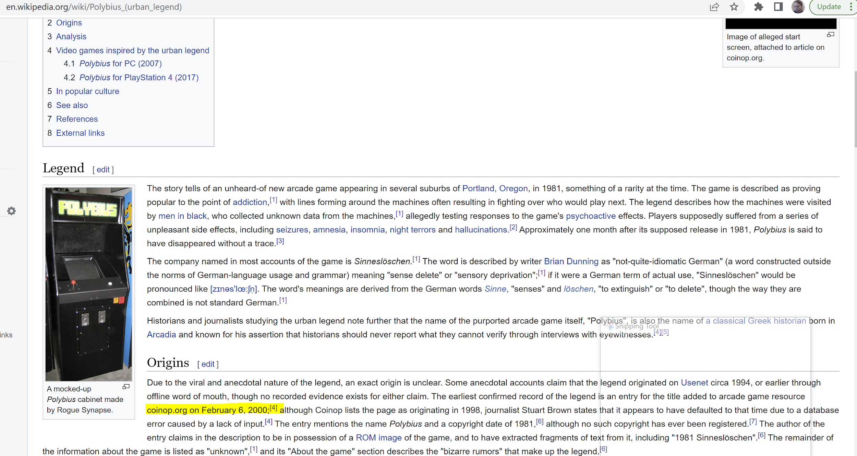
>JR: and see thats what gets me about zampanio
>JR: polybius has a distinct start and end
>JR: but i can BARELY even find the things that lead me to zampanio in the first place
>JR: its all dead ends of unmarked possible fanworks
>JR: and quote collections
> JR: dont get me wrong, carol shaws fanwork was AESTHETIC and she musta played it really early on but....
>JR: not the same
> KR: I think you're looking in the wrong places. old internet was about connections. you want forums, ideally, or web rings - places where people gathered.
JR: yeah but where do you even FIND old forum or webrings. wayback is hard to search
> Catalyst: KR descends upon us yet again with a gift of knowledge of old obscure internet culture
JR: if only i had the brain cells to use it
JR: i know the whole point of the old internet is it was free of the tyranny of the horrorterrors Algorythm
JR: but damn if it doesn't make it hard to find anything
JR: even when you have direct quotes
> Taxonomist: anyone want to spread the word of Zampanio in r/place?
>JR: oo sounds fun
> Taxonomst: idk if the void is trying to take over again but I should get a post made about zampanio on r/place now (if we figure to what to make)
>JR: something based on Truth?
> taxonomist: tanks (this is not a typo)
JR: tho im headed out for an hour or two, and IC'll be back sometime
> Where is the game?
JR: sburbsim goes down every april fools, no one can stop it so we just colonize wherever it points to for a day and hang out, solve secrets
> taxonomist: made it link
> CD: yo what's been going on in here i've been at school
JR: we're looking for Zampanio on the Old Web
JR: I KNOW i learned about while we were finding things to shove into the knuckles sux blog
> Catalyst: I read that as "based Truth?" and yes... yes they are
JR: truth is so based
> I am trying to use the SBURB simulator and it keeps bringing me here
JR: honestly the steady trickle of confused SBURBSim users really adds to the ambiance
> Math: What percent of the Old Internet was cats?
> JR: 100% anything that looked like it wasn't a cat was lying to you
> Math: How long before 100% of my lap is cat.
> JR: its already happened. make sure to pet your laptop
> weaver: finally im at home where adventuresim works!!! anyway not much to say so far im just readin through the backlog here
JR: hell yes glad you could make it weaver
> JR: okay update, turns out the old internet stole my funimation watch list, no i will no will not elaborate
> jr: oh shit i wonder if i can find the spiral graphic i stole
jr: no but i can find yet another Truth
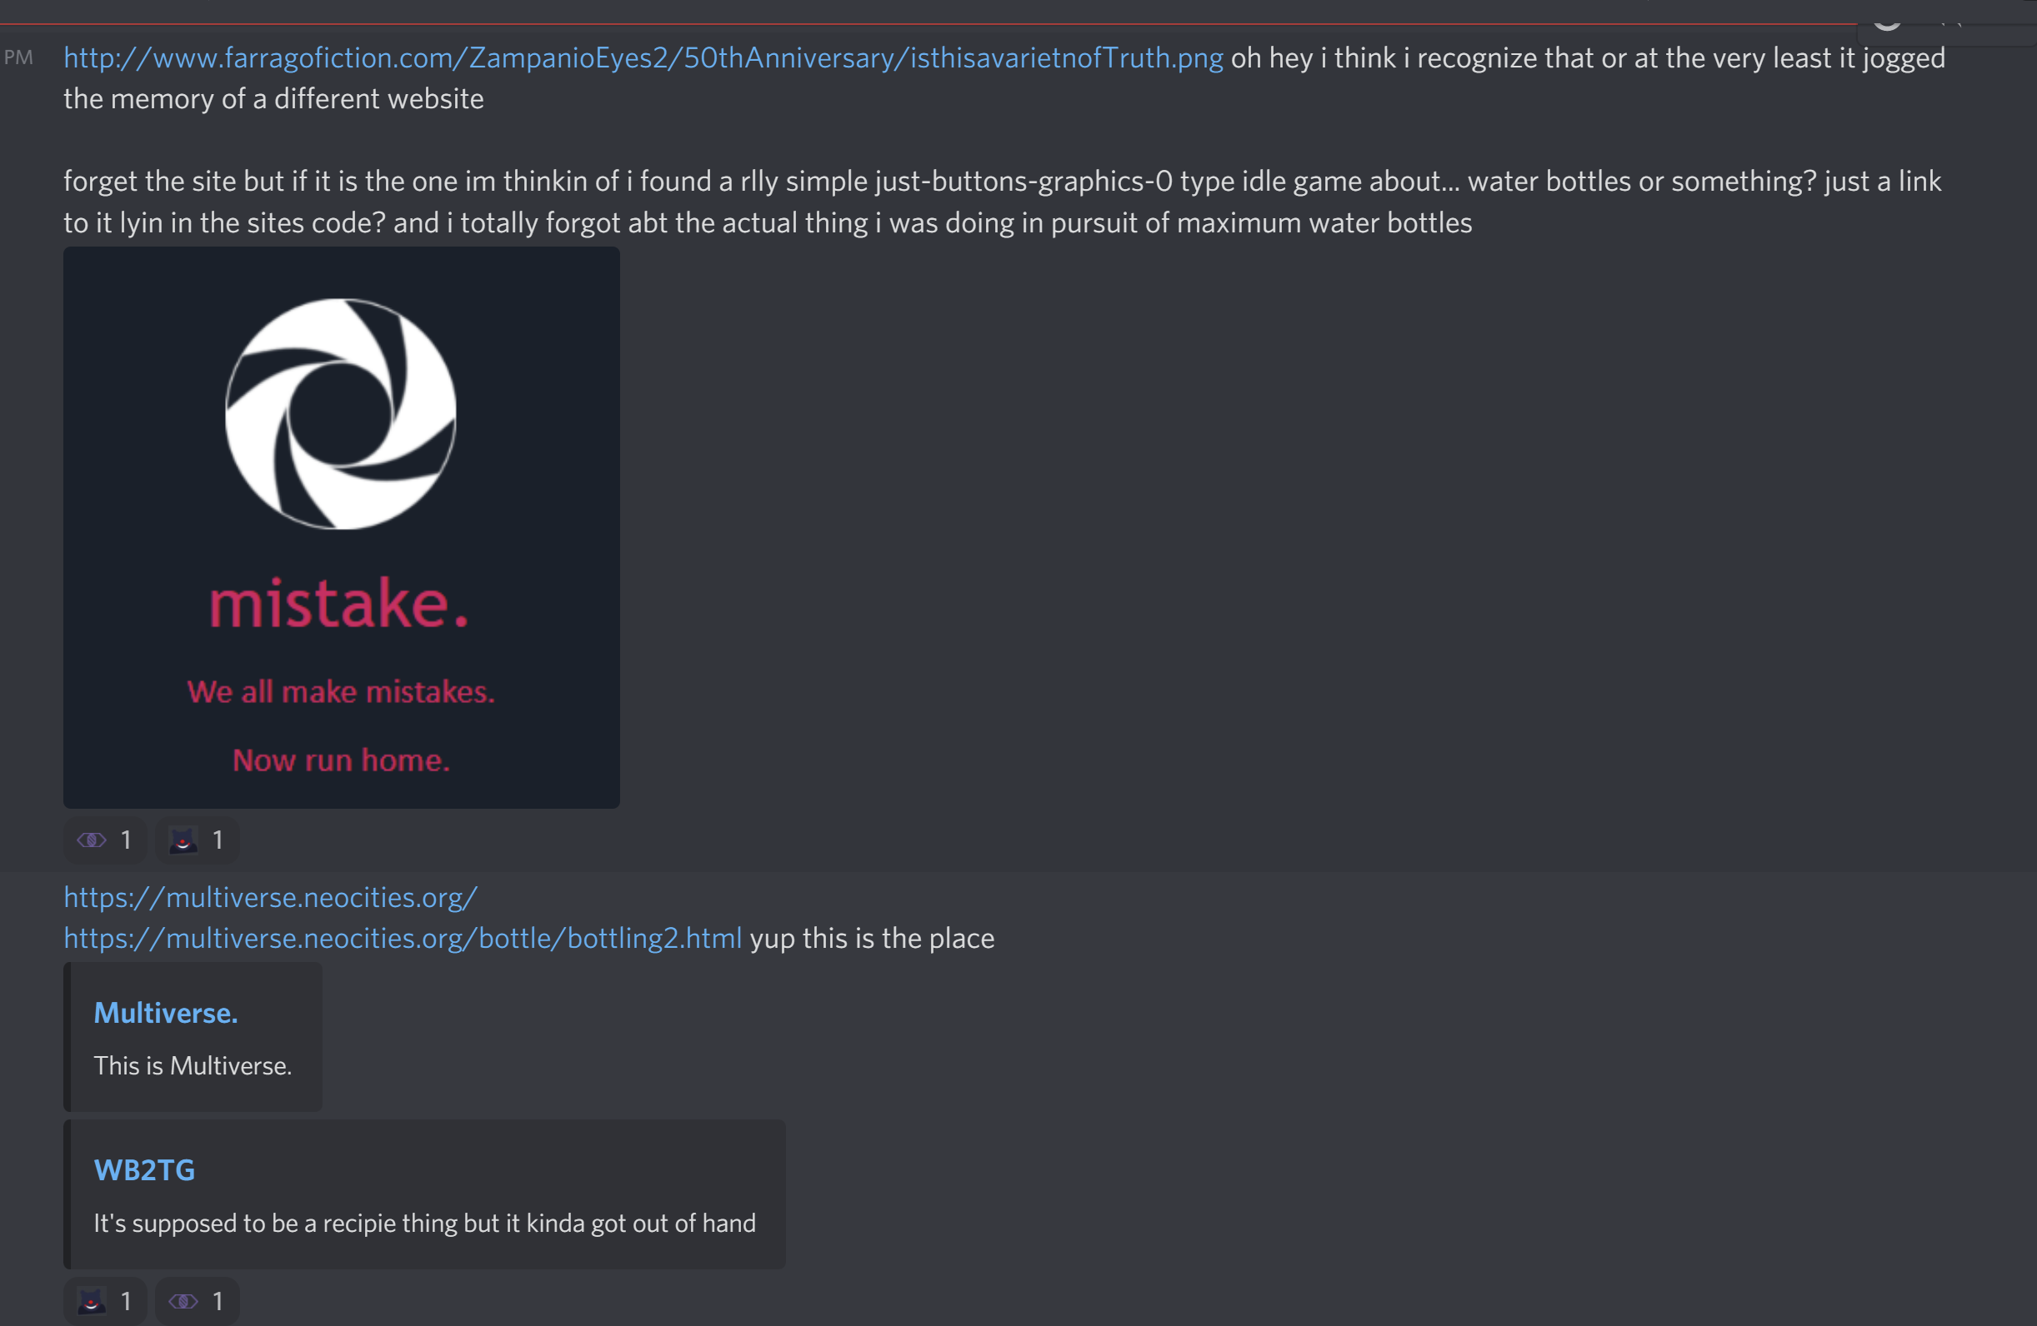
JR: You know what? Not the puzzle i was going for but why not. One more free Eye Killer question you can get answered to the best of our ability.
> da fuq is happening
JR: we're celebrating april fools day via colonizing the space sburbsim yeets ppl into automatically
> ???: favorite flash?
JR: names aren't real btw
JR: aaaaalsooo...
JR: man flash has been dead for so long i can't even remember
JR: rip to any zampanio clues that were stored there
> I know I'm kinda spamming but favorite episode of Homestuck:The Anime?
JR: actually i like the live action movei better.
> weaver: i am not who the question was directed at but depict1 is a pretty fun ride
> weaver: rlly so many of the flash games i used to play are just. Gone at this point. shame.
>JR: its a damn shame
JR: the Mathematician was telling me about A Tale In the Desert which had huge zampanio vibes.

> JR: wait link broke? http://farragofiction.com/HomestuckTheMoive/
it thinks its https
trying agian
> Unmarked: unfortunately, th3 natur3 of th3 old web is its' elusiveness. And I d0 not know what would draw zampanio out.
JR: mood
JR: actually if yall have nothing specific about the eye killer you can ask 1(one) more general question but you won't get a second bonus question possibilty
> Catalyst: nah give us time, we'll figure out something to ask... probably
JR: lol okay
> Catalyst: also what's up with deserts and mathematicians? this is the second time I see a math enthusiast love the desert
>JR: something about featureless infinite planes maybe?
> video prompt:JR has a gun (I'm sorry for spamming)
JR: run
> Catalyst: wait this reminds me, the wiki page for Spiral mentions sand... sand = desert ok, don't @ me
JR: lol and math is associated with fractals
> I'm reading the entirety of HomestuckTheMoive because I can.
lol its just canon but with dumb art
Math: http://www.purplefrog.com/~thoth/art/uzumaki/uvsquare.html
>jr: holy shit
>jr: its best quality?
>jr: its wiggles
>jr: truth fanart ftw
> Catalyst: yooo that looks great
JR: have i mentioned the mathematician is my mentor? he banged that out in like, a half hour after we found a static version on a wayback site just now
> Catalyst: they made the thingy on LORAS too, right? impressive math skills
JR: yup yup, they did the math, they hosted the original sim, too
> <p>JR: thinking about it</p>
JR: didn't yall leave me a gun in AdventureSim
> Herald: they what
JR: i have a gun now
> since your the expert who would win, Zingo the Clown or Fresh Death?
JR: the what now? oh right, big bads from sbursbim. honestly? no way to tell, sburbsim is down
> Taxonomist: I am full of memetic hazards
JR: same tbh
> Catalyst: oh right we tried to get rid of the gun this loop and JR being the little trash creature they are probably picked it up from the void
JR: look i learned my lesson
JR: not gonna just leave those lying around after use
> Taxonomist: I was the one who used the gun
JR: you know
JR: tbh
JR: im not surprised
> Catalyst: oh you mean to shoot the cop, Crow? dw I tried to shoot it too, and literally every observer tried to fight the cop anyway
JR: yall are really fighty
JR: poor peewee
> Taxonomist: I want blood
JR: peewee just wants to live his life
JR: and you know
JR: destroy the universe
> Herald: zampaniosim more like gun violence sim
> Catalyst: WHY does he wanna destroy the universe, his goddamn children live there come on
JR: is this your question?
> taxfraud: does zampaniosim save us from heat death or nah
JR: definitely does not
> Catalyst: ok no no no don't answer, I'm waiting for the Answer to ask something Killer related
>JR: lol
> taxfraud: it be like that sometimes, the breadbank just opened at this time of eternity and i am disappointed
JR: ???
> taxfraud: it be like that sometimes, the breadbank just opened at this time of eternity and i am disappointed
JR: ???
> Taxonomist: ok I have an idea, image of Peewee with captions saying "full of corruption"
JR: full of milk, full of year
> Answer: destroying the universe would be fun!
JR: could be , could be
> IC: BTW
IC: Just in case anyone was wondering, the lesson learned today is that there's too many oreo flavors
> Detective: how's it going over ther3?
JR: congrats on the title
> Herald: today i learned that there are different oreo flavors
>JR: too many
>> weaver: i think im like the one person actively trying to avoid gettin this guy into violent situations. i just want peewee to live his life hhh i try to help him but its definitely Hard sometimes
>JR: i appreciate this
> Answer: trying to play ace attorney in this is hard, since i dont know how the legal system works
jr: neither does wanda, so don't sweat it
> taxonomist: thinking about cinnamon bun oreos
jr: caramel coconut oreos are p good
> Herald: the thought of wanda participating in the legal system terrifies me
jr: same tbh
> Detective: you know that phenomenon when you learn about a new thing and suddenly it's everywher3? that's m3 with echidnas right now
jr: im hoping one day we can get zampanio back to that level as a concept.
jr: where people learn of it and then see it everywhere
> Answer: and everything will be a zampanio reference
JR: you get it
JR: btw im going to bed in an hour or two so ask yalls final question before then
> Taxonomist: final question
> Answer: Yo, can i get info on Eye killer's funny little ghost robot man accomplice, for uh, 200
IC: its NAM
JR: accomplice is a STRONG word but then The Innocent is havin' some strong feelings
JR: actually depending on accomplice to WHAT i guess
JR: buuuut thats gonna be in the story soon enough
> jr: > did yall know that watt is in the friday night funkin mod because he *canonically* and i can't stress this enough, was good enough at ddr to gain INFINITE POWER and used it to crash an entire ass satellite onto the earth?
https://cdn.discordapp.com/attachments/468574691087613952/959642842865733652/video0.mov
> wait link
video0.mov
> Herald: friday night funkin: watt fucking snaps edition
jr: he really did
jr: to commemorate this, and other things from his source, when he was in the rp setting i dmed he could just...kill everyone in a room. any time he wanted. everyone at once.
jr: have i mentioned i don't care about balance?
> jr: friendly fire enabled ofc
> Herald: why, and also did he do this
jr: because he's a entire power generator on legs.
jr: i think he did it twice?
jr: because the downside was that if wyatt ever got too stressed he HAD to do it and ronin would get unencrypted
jr: in that game setting if you got too stressed you had to lose a scene doing therapy with doc slaughter
> jr: here i found his char sheet from it
Wyatt Mann is a young, scrappy rookie who is very much a human being, and not suspicious at all. Only a few years into the force after being created by his ‘father’ figure, an eccentric conspiracy theorist forensic scientist looking to create someone to trust BEING BORN AT SOME POINT IN THE PAST AMOUNT OF YEARS, Wyatt tries his best to solve the crimes that come his way! If only he had any idea what exactly is supposed to be going on in any given case, or any rules he has to follow, or if there even ARE rules, or what a cop is supposed to do.
It’s okay, though. No matter what, he never stops smiling! Ever.
Traits:
- Robot MECHANIC
- Sparks Joy
- Dutiful
- Loyal
- Ascended Social Anxiety
Ability: Zap-- can apply a mild electric charge (not enough to do damage) to any single target (object, person, whatever) for free. For 1hp can do half the remaining hp of everyone (friend and foe) "nearby", or 2hp, whichever is greater. If down to one stress point, will do the 1hp zap automatically.
So wyatt was the player char, but we figured out there was the entire damn alphabet of Watts his creator had made. The previous two, Wwatt and Wxatt were npcs in the plot. W was erased (and became the Mysterious Stranger who became NAM ) and X was one of the murder victims the players were investigating.
jr; ah, good times
> gonna log off as well, good night adventure-ers!
jr: yeah think im wrapping up as well
> ascended social anxiety
jr: honestly i should give peewee an ability that yall can use once a scene
> ic: was "gun" not enough for you
jr: okay point
jr: so if peewee had Traits, what would they be
jr: Gamer, obviously...
> jr: puppet, i could see that being useful
IC: gamer is the most powerful one
IC: speedrunning strats
IC: he can grind, you know
JR: you have a point
> weaver: just wanna say since u mentioned wrapping up, b4 u officially go (in case i end up missing it) that this has been rlly fun even if i wasnt like super active through most of it. its been rlly nice
JR: hell yes, its been fun
JR: glad i took the day off for this
> Herald: speaking of fnf, what's the context of that one animation on github where watt gets fucking yoinked
JR: theres a lost expansion that includes a duet with ronin
JR: but nearly all the art assets for it got lost
> jr: the best part of it is the ronin parts were all show offy and fast
jr: and the watt parts were all slow and "lets play together"
jr: the SONG is still in there
jr: but its less obvious that its two parts in tandem
jr: without the assets
>weaver: wow, rip
> Herald: is this song somewhere we can find
jr: yeah its in the mod you can find in zampaniosim
jr: its the final song iirc
jr: it just never got the final art assets
> Herald: wait is it cyberstorm? that would explain the parts where he randomly starts making guitar noises
jr: that sounds right
jr: its part of zampanio cuz i wanted to make sure something so cool didn't end up lost to time
jr: just because part of it was lost
jr: honestly a lot of my take on zampanio is rooted in that feeling
jr: unfinished stories
jr: lost media
> jr: alright, gonna restore lifesim to what it used to be
JR: MOST ppl who cared about this probably are at the normal link
JR: and for any lurkers who got exposed to this system for the first time today
JR: and don't know what *any* of this means/p>
JR: if you're curious/p>
JR: http://farragofiction.com/AdventureSimWest/
that's where you can normally find this.
JR: its part of ZampanioSim
JR: my love letter to the mysterious creepy pasta i know i found but can't refind
JR: even after a day of trying i found only crumbs
JR: rip
JR: but yeah, i'll set this to an intermission
JR: and restore the courtroom drama
JR:its been fun
JR: thank you for joining me on this celebration of the 50th year anniversary of the weirdest, most confusing game ive ever heard of
JR:it really does mean a lot

